**Design and Implementation of Single Precision FPU in RISC-V Processor**



Final year project report submitted in partial fulfilment of requirement for degree of Bachelors of Science in Electrical Engineering

|  |  |
| --- | --- |
| Arslan Ahmed | NIM-BSEE-2021-09 |
| Nasir Abbas | NIM-BSEE-2021-35 |
|  |  |

Dr. Naureen Shaukat

**Department of Electrical Engineering**

**Namal University, Mianwali**

**2025**

**DECLARATION**

The project report titled “Design and Implementation of Single Precision FPU in RISC-V Processor” is submitted in partial fulfilment of the degree of Bachelors of Science in Electrical Engineering, to the Department of Electrical Engineering at Namal University, Mianwali.

It is declared that this is an original work done by the team members listed below, under the guidance of our supervisor “Dr. Naureen Shaukat”. No part of this project and its report is plagiarised from anywhere, and any help taken from previous work is cited properly.

No part of the work reported here is submitted in fulfilment of requirement for any other degree/ qualification in any institute of learning.

**Team Members Signatures**

Arslan Ahmed NIM-BSEE-2021-09 ______________

Nasir Abbas NIM-BSEE-2021-35 ______________

**Supervisor**

Dr. Naureen Shaukat **Signatures with date** ____________________

**Table of Contents**

Abstract vi

1. Introduction 1

1.1. RISC-V Processor 1

1.2. Background 1

1.3. Purpose 2

1.4. PicoRV32 2

1.5. Floating Point Unit 2

1.6. SDG’s Goals 3

1.6.1. SDG Goal 9: Industry, Innovation, and Infrastructure 3

2. Literature Review 5

2.1. FPUs in Processor Architectures 5

2.2. Challenges in FPU Design 5

2.3. Hardware Validation and FPGA Implementation 6

3. Methodology 7

3.1. Design Process: 7

3.1.1. Architecture Study 8

3.1.2. Selection of PicoRV32 Core 9

3.1.3. Verilog Learning and Practice 10

3.1.4. PicoRV32 Core Understanding 10

3.1.5. Floating Point Unit 12

3.1.6. FPU Module Design 13

3.1.7. FPU Integration with PicoRV32 14

3.2. Mathematical Model 20

3.2.1. IEEE-754 Single Precision Format Structure 20

3.3. Algorithm 22

3.3.1. Floating-Point Addition/Subtraction (fp_add_sub) 22

3.3.2. Floating-Point Multiplication (fp_multiply) 23

3.3.3. Floating-Point Division (fp_divide) 24

3.3.4. Floating-Point Square Root (fp_sqrt) 25

3.3.5. Floating-Point Comparison (fp_compare) 25

3.3.6. Floating-Point Load/Store (lw/sw) 26

3.4. Block Diagram 26

3.5. Implementation Constraints 30

4. Testing 32

4.1. Purpose of Testing 32

4.2. Testing Methodologies 32

4.3. Test Cases Description 33

4.4. Result Observation Methods 34

4.5. Verification Strategy 34

4.6. Integration Testing 35

4.7. Tools Used 36

4.7.1. RISC-V GCC toolchain 36

5. Results 38

5.1. PicoRV32 Synthesis Using Yosys 38

5.1.1. Project Setup and Repository Cloning 38

5.1.2. Compilation and Testing Process 39

5.1.3. Functional Verification and Testing 40

5.1.4. Performance Analysis and Metrics 42

5.1.5. Synthesis Preparation with Yosys 43

5.2. FPU Functional Results 43

5.2.1. FADD.S (Floating Point Addition) 44

5.2.2. FSUB.S (Floating Point Subtraction) 45

5.2.3. FMUL.S (Floating Point Multiplication) 45

5.2.4. FDIV.S (Floating Point Division) 46

5.2.5. FSQRT.S (Floating Point Square Root) 47

5.2.6. FMIN.S, FMAX.S (Floating Point Minimum,Maximum) 48

5.2.7. FEQ.S, FLT.S, FLE.S (Floating Point Comparison) 49

5.3. FPGA Result 51

6. Discussion 53

7. Conclusion 55

8. Future Work 56

9. Reflections on Learning 57

10. References 58

11. APPENDICES 60

**List of Figures**

Figure 1: Design stages 7

Figure 2: Cores Comparison 10

Figure 3: PicoRV32 Core modules 11

Figure 4: Block Diagram of PicoRV32 11

Figure 5: FPU Block Diagram 13

Figure 6: FPU Instruction Decoding 16

Figure 7: FPU PCPI 16

Figure 8: FPU Integration 19

Figure 9: IEEE-754-2008 Standard [4] 20

Figure 10: ADD/SUB Module 23

Figure 11: MUL module 24

Figure 12: FPU Microarchitecture 27

Figure 13: PicoRV32 Microarchitecture [13] 28

Figure 14: Modified Block Diagram 29

Figure 15: Addition Result 44

Figure 16: Subtraction Result 45

Figure 17: Multiplication Result 46

Figure 18: Division Result 47

Figure 19: Square Root Result 48

Figure 20: Minimum Result 48

Figure 21: Maximum Result 49

Figure 22: FEQ Result 50

Figure 23: FLE Result 50

Figure 24: FLT Result 51

Figure 25: FPGA Implementation 52

**List of Tables**

Table 1: PicoRV32 Implementation (LUTs) 9

Table 2: FPU Opcodes 14

Table 3: Synthesis report 30

Table 4: With and without FPU 36

**ACKNOWLEDGMENTS**

This project's success was not solely due to our efforts, but also the contributions of many other individuals who played crucial roles in its completion. We would like to express our sincere appreciation to our professors, who have been instrumental in shaping our project's success through their valuable guidance and encouragement.

We are truly appreciative to our Respected supervisor, Dr. Naureen Shaukat, for all of her help, encouragement, and support during this project. Her expertise and views were crucial in forming this work and advancing us. We really appreciate the ways in which she has assisted us, such as with weekly base progress reports, developing complicated concepts, offering constructive feedback, and assisting with obstacles.

We also want to express our sincere gratitude to one another for our outstanding teamwork, commitment, and tenacity during these endeavours. By cooperating, we overcame obstacles and accomplished our goals.

We also express our gratitude to our friends and colleagues for their moral support and useful advice. Finally, we would especially want to thank our families for their unwavering support and tolerance during this difficult project phase.

# Abstract

RISC-V, an open-source instruction set architecture, has characteristics of high performance, modularity, simplicity and easy expansion therefore numerous open- source cores have been employed in academia and commercial projects within a few years. Floating-Point Units (FPUs) are essential for the calculations of floating-point numbers. The project aims to design a Single Precision Floating-Point Unit (FPU) and its integration into RISC-V based processor PicoRV32 which lacks dedicated FPU. FPU is suitable for performing arithmetic and logical operations on floating point numbers. The FPU is designed according to the IEEE-754-2008 standard. To support FPU, different modules like a register file are updated to store floating point numbers, and the decoder is updated to accommodate the floating-point instructions. FPU is integrated as a coprocessor in the PicoRV32 processor core and implemented on Field Programmable Gate Array (FPGA) for hardware verification. The results confirm the successful integration of the designed module in the core. Tests are conducted to compare the core’s performance without FPU and with FPU, ensuring that integrated FPU significantly enhances the core’s performance of handling floating point numbers.

*Chapter 1*

# Introduction

This section covers key preliminary concepts essential for understanding the upcoming project details.

* RISC-V Processor
* Background
* Purpose
* PicoRV32
* Floating Point Unit
* SDG’s Goals

## RISC-V Processor

The processor is the brain of a computer that helps to execute different instructions and perform various calculations. With the advancement in technology, the number of processors is increasing day by day so there are numerous processors available in the market. Companies are working on them to make them according to the needs of the customers and their use. Due to the dynamic nature of the market, the count is not possible. On a regular basis, they are created, modified, and changed to meet better performance and power requirements. RISC-V is a new kind of royalty-free architecture committed by the engineers at University of California, Berkeley [1]. RISC-V is open standard instruction set architecture (ISA) based on the established reduced instruction set principle. Now it is gaining popularity in processor design under open-source licenses in specific applications such as Storage devices, Edge Computing and AI applications.[2]

## Background

RISC-V based processors have changed the way to design processors. In the beginning, the processors were designed using the CISC approach, which was complex for new designers. However, this ISA is open source and allows a wide range of customization options to help computer architects design a processor according to their need. The best thing about RISC-V processors is that they are simple, flexible, open source, and modular. Due to its open source, modularity, scalability and simplicity billions of cores have been built by using its ISA [2]. Developers optimize their designs according to their application requirements. This finds applications in both academic and commercial designs because it is free to use.

## Purpose

The main objective of the project is to design a single-precision Floating-Point Unit (FPU) for the PicoRV32 core that will be in accordance with IEEE 754-standard. This FPU will be able to perform accurate floating-point calculations, including many operations such as addition, subtraction, multiplication, and comparisons between numbers. The implementation of FPU integrated core on a Field Programmable Gate Array (FPGA) will enable core testing and validation under real-world conditions, ensuring its reliability and efficiency. 1 Ultimately, this research aims to overcome the constraints of lightweight RISC-V cores through the design of an efficient and resource-conscious single-precision FPU. The project’s success will be demonstrated through rigorous hardware testing and its potential applications, offering valuable insights into academic and technological development.

## PicoRV32

PicoRV32 is a RISC-V core developed by Clifford Wolf and open-sourced for open contributions. PicoRV32 is a CPU core that implements the RISC-V RV32IMC Instruction Set, Integer (I), Multiply/Divide (M) and Compressed (C) extensions. It can be configured as RV32E, RV32I, RV32IC, RV32IM, or RV32IMC core, and optionally contains a built-in interrupt controller. It supports the optional Pico Co-Processor Interface (PCPI) that can be used to implement non-branching instructions in an external coprocessor [3]. By implementations of PCPI any Standard Extension instructions can be integrated in PicoRV32.

## Floating Point Unit

Modern computing systems depend significantly on floating-point arithmetic to process real numbers accurately and with a wide dynamic range. This arithmetic capability is vital for numerous applications, such as scientific studies, digital signal processing and engineering simulations. The IEEE 754 standard for floating-point arithmetic provides accurate processing of floating-point integers [4]. RISC-V architecture has different core processors, the processor cores like PicoRV32, lack a dedicated Floating-Point Unit (FPU), which restricts their performance in high precision tasks. The small cores like the PicoRV32 are designed to minimize hardware complexity and energy consumption, which can compromise their computational strength. But a problem with this is they lack FPUs. This problem can be resolved by introducing a single-precision FPU that adheres with IEEE 754-standard, which will significantly improve PicoRV32’s ability to meet advanced computational requirements. In the integration process, there are some fundamental changes to the PicoRV32, including modifications to its register files, decoder unit and control logic to handle floating-point data and instructions. This will not only improve the core’s computational capabilities but also support the goals of open-source hardware innovation [5].

## SDG’s Goals

The Sustainable Development Goals (SDGs) are 17 global goals adopted by all United Nations Member States in 2015 as part of the 2030 Agenda for Sustainable Development. These goals aim to address major global challenges such as poverty, inequality, climate change, environmental degradation, peace, and justice. Each goal is broad, measurable, and has specific targets and indicators to track progress.

### SDG Goal 9: Industry, Innovation, and Infrastructure

Sustainable Development Goal 9 (SDG 09) focuses on building resilient infrastructure, promoting inclusive and sustainable industrialization, and fostering innovation. Our project aligns strongly with these objectives by contributing to advancements in processor architecture and embedded systems [6].

#### Objectives:

* Develop quality, reliable, sustainable, and resilient infrastructure
* Promote inclusive and sustainable industrialization
* Enhance scientific research, upgrade technological capabilities, and foster innovation

#### Project relation with SDG 09

By equipping the open-source PicoRV32 RISC-V processor with a custom-designed single precision Floating Point Unit (FPU), our work supports innovation in digital hardware design and embedded computing. This enhancement improves the processor’s performance in scientific research and computationally intensive applications, contributing to the development of sustainable and high-performance digital systems.

Our project involves RISC-V processor enhancement, FPU design, and embedded system development—key areas that relate directly to SDG 09 through:

* Innovation & Research: Advancing custom hardware design and fostering practical research in processor development.
* Industry Readiness: Equipping students with hands-on skills in digital design, system integration, and FPGA implementation.
* Infrastructure Development: Contributing to the creation of reliable, scalable, and sustainable computing infrastructure using open-source technologies.

Through these contributions, our project supports the broader goals of SDG 09 by promoting technological innovation, education, and sustainable digital infrastructure.

*Chapter 2*

# Literature Review

The development and optimization of Floating-Point Units (FPUs) have been extensively researched due to their critical role in modern processors. FPUs enable processors to perform floating-point arithmetic efficiently, a fundamental requirement for fields like scientific computation, real-time graphics, and advanced system processing. The IEEE 754 standard, established in 1985, has been instrumental in defining consistent and accurate methods for floating-point representation and operations, ensuring uniformity across hardware and software platforms [4].

## FPUs in Processor Architectures

The integration of FPUs into processors significantly enhances their computational capabilities. For instance, Murali Krishna et al. (2013) demonstrated the advantages of incorporating FPUs for handling both simple and complex arithmetic operations [7]. Their design emphasized reducing hardware complexity while improving resource utilization. Similarly, Harshita Nair et al. (2020) presented an efficient implementation of single-precision floating-point operations on FPGA platforms [8]. By employing techniques such as pipelining and truncation, their work achieved notable improvements in speed and area efficiency, adhering to IEEE 754 guidelines. Despite advancements in FPU designs, lightweight cores like PicoRV32 often omit FPUs to maintain simplicity and energy efficiency. This exclusion limits their application in tasks requiring high precision and computational power. Addressing this challenge, Saghir (2010) highlighted the potential of application-specific instruction-set architectures in balancing performance with resource constraints [9]. This perspective aligns with the objectives of this research, which seeks to integrate an efficient FPU into the PicoRV32 core.

## Challenges in FPU Design

The design of FPUs poses several challenges, including hardware complexity, compliance with IEEE 754 standards, and optimization for power, area, and latency. Innovative architecture is being designed to address these challenges, emphasizing reduced lookup table usage and improved precision without excessive resource overhead. Harshita Nair et al. (2020) further explored trade-offs between latency and area, showcasing designs that achieve compactness and efficiency [8]. For the PicoRV32 core, integrating an FPU requires significant modifications to its microarchitecture. These changes include updating register files to support floating-point data and adapting control logic to handle floating-point instructions. Louca et al. (1996) discussed similar architectural adjustments necessary for enabling floating-point operations in lightweight processors, providing valuable insights for this project [10].

## Hardware Validation and FPGA Implementation

The practical validation of FPU designs often involves implementation on FPGA platforms. FPGAs provide a flexible and efficient means to test and refine hardware architectures. Harshita Nair et al. (2020) demonstrated the use of Xilinx FPGAs to validate single-precision floating point designs, highlighting the importance of efficient mapping and synthesis techniques [8]. The Xilinx Artix-7 FPGA, selected for this project, offers an optimal balance between resource availability and computational capability. Testing the designed FPU on an FPGA ensures its functionality and performance under real world conditions. Patterson and Hennessy (2020) emphasized the significance of hardware validation in processor design, noting its role in identifying and addressing architectural bottlenecks [11]. By leveraging FPGA testing, this research aims to refine the integrated PicoRV32 core, ensuring it meets its intended objectives of enhanced computational precision and efficiency.

*Chapter 3*

# Methodology

The methodology adopted in this project followed a structured and practical approach that guided the complete development of the Single Precision Floating Point Unit (FPU) and its integration into the PicoRV32 RISC-V processor core. Our process began with foundational study, gradually transitioning to module design, simulation, integration, and finally hardware testing.

## Design Process:

The design process of our project involves major phases through which the proposed work is completed. The figure below illustrates the three main stages followed during the project development lifecycle:

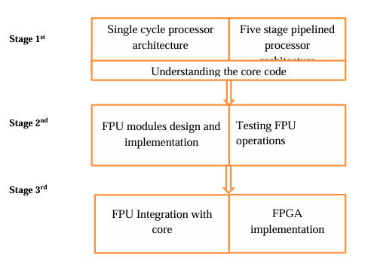

Figure : Design stages

In Stage 1, we focused on building a strong understanding of processor architecture. This included a study of both single-cycle and five-stage pipelined RISC-V processor models to understand basic instruction flow, control, and datapath. Simultaneously, we studied the PicoRV32 RISC-V core codebase to comprehend how it handles instruction decoding, register access, control signals, and execution flow [3]. This stage formed the theoretical base for later hardware-level design work.

In Stage 2, we began designing the FPU according to the IEEE-754 single precision format [4]. This included modules for basic arithmetic operations such as addition, subtraction, multiplication, and division. Each module was implemented in Verilog and tested using simulation environments like ModelSim. Various input test cases were used to verify correctness and IEEE compliance. After functional verification, we proceeded to Stage 3, where the verified FPU was integrated into the PicoRV32 core using the PCPI interface. The integration involved modifying the instruction decoder, handling PCPI handshake signals, and ensuring multi-cycle support within the processor’s control state machine. Finally, the complete design was synthesized and deployed on an FPGA board for real-time hardware testing [8].

The complete design methodology followed throughout the project is summarized in the following stepwise process:

* Architecture Study
* Selection of PicoRV32 core
* Verilog Learning and Practice
* PicoRV32 Core Understanding
* Floating Point Unit
* FPU Module Design
* FPU Integration with PicoRV32

### Architecture Study

At the beginning of our project, we had limited background in computer architecture and hardware design. Therefore, our first step was to build a solid understanding of RISC-V processor architecture. The foundation of our project began with an in-depth study of processor architectures to build a solid understanding of how instructions are executed within a CPU. We started by analysing the single-cycle processor architecture, where each instruction completes its execution in a single clock cycle. This model helped us understand the fundamental components such as the instruction fetch unit, register file, ALU, control unit, and memory access mechanisms. After gaining confidence in the single-cycle model, we moved to the five-stage pipelined processor architecture, which breaks the instruction execution into five stages: Instruction Fetch (IF), Instruction Decode (ID), Execute (EX), Memory Access (MEM), and Write Back (WB) [11]. This pipelined structure allowed us to understand concepts like data hazards, control hazards, forwarding, and stalling mechanisms, which are essential for efficient processor design.

The goal of this architectural study was to develop the necessary background for working with a real RISC-V core—PicoRV32, which is a lightweight, compact, and configurable processor core based on the RISC-V ISA. Through this study, we became familiar with how instructions flow through the datapath, how control signals are generated and handled, and how custom functional units (like our FPU) can be attached. This understanding was critical for identifying the correct integration points in the PicoRV32 core, particularly for instruction decoding, operand fetching, and handling execution results through the PCPI (Pico Co-Processor Interface). Overall, this stage laid the theoretical groundwork needed to move forward with design, implementation, and integration tasks in the later stages of the project.

### Selection of PicoRV32 Core

In our project, we selected PicoRV32, a compact and flexible 32-bit RISC-V CPU core, to serve as the base processor for integrating our custom-designed Single Precision Floating Point Unit (FPU). The key reason behind choosing PicoRV32 was its support for the Pico Co-Processor Interface (PCPI), a dedicated hardware interface that allows external custom modules to be attached to the processor without altering the internal datapath of the core [3]. This was ideal for our design goal, as we needed to add an IEEE-754 compliant FPU without disturbing the existing core functionality.

PicoRV32 supports the RV32IMC instruction set, which includes integer instructions (RV32I), multiplication/division operations (RV32M), and compressed instructions (RV32C). This made it suitable for embedded applications and academic projects like ours. Additionally, PicoRV32 is designed to be highly configurable, allowing optional support for features like interrupts, different register file implementations, and memory interfaces (native, AXI, or Wishbone). Its small footprint (750–2000 LUTs) and high-frequency operation (250–450 MHz) on modern FPGAs made it a practical choice for implementation and testing on real hardware [3]. Furthermore, the community support, open-source availability on GitHub, and thorough documentation made it easier for us to understand, modify, and extend.

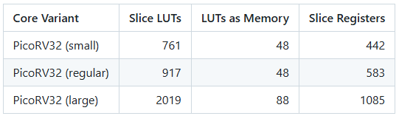

Table : PicoRV32 Implementation (LUTs)

Another cause in its selection is due to its extremely low LUT utilization compared to other RISC-V cores. As shown in the chart, it uses only 904 LUTs, making it one of the most lightweight and resource-efficient options available. In contrast, cores like BOOM require over 49,000 LUTs, which are unsuitable for small FPGAs. This efficiency allows for easier integration of custom modules like our FPU while maintaining overall hardware simplicity.

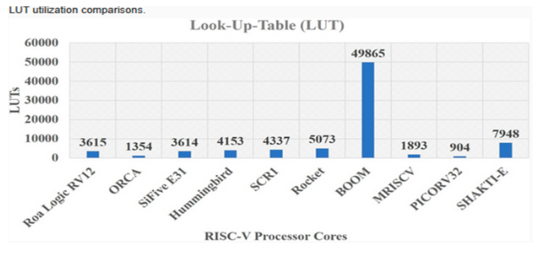

Figure : Cores Comparison

### Verilog Learning and Practice

To design and integrate our custom FPU, we first developed a strong understanding of Verilog, the primary hardware description language used throughout the project. We began by learning the syntax, data types of Verilog through small example modules and simulation exercises. Emphasis was placed on writing combinational and sequential logic, creating testbenches, and simulating using ModelSim to observe signal behavior and debug logic errors. We also practiced designing finite state machines, ALU operations, register files, and memory modules to strengthen our grasp of hardware-level design [11]. This hands-on practice with Verilog formed the essential skill base for successfully implementing the FPU and modifying the PicoRV32 core for integration.

### PicoRV32 Core Understanding

The internal architecture of the PicoRV32 processor is structured into several interconnected modules, each handling a distinct function in the instruction execution cycle. At the top level is the PicoRV32 Main Processor which coordinates the overall flow of data and control within the processor core [3]. The central controlling element is the Main State Machine, which governs the step-by-step execution of each instruction, from fetching to write-back. It interacts directly with all major components, ensuring proper sequencing and control.

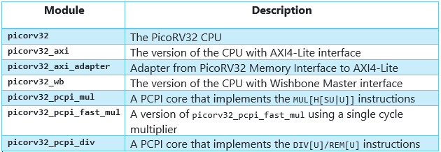

Figure : PicoRV32 Core modules

Instructions are first fetched from memory via the Memory Interface, which is responsible for reading instructions and accessing data. The Instruction Decoder then decodes the fetched instruction, identifies its type (arithmetic, memory, branch, etc.), and generates the appropriate control signals. These signals guide the data flow to the required units. Operands required for the instruction are fetched from the Register File, which contains 32 general-purpose registers (x0 to x31). The results of operations, once computed, are written back to the register file. The main block diagram is here below:

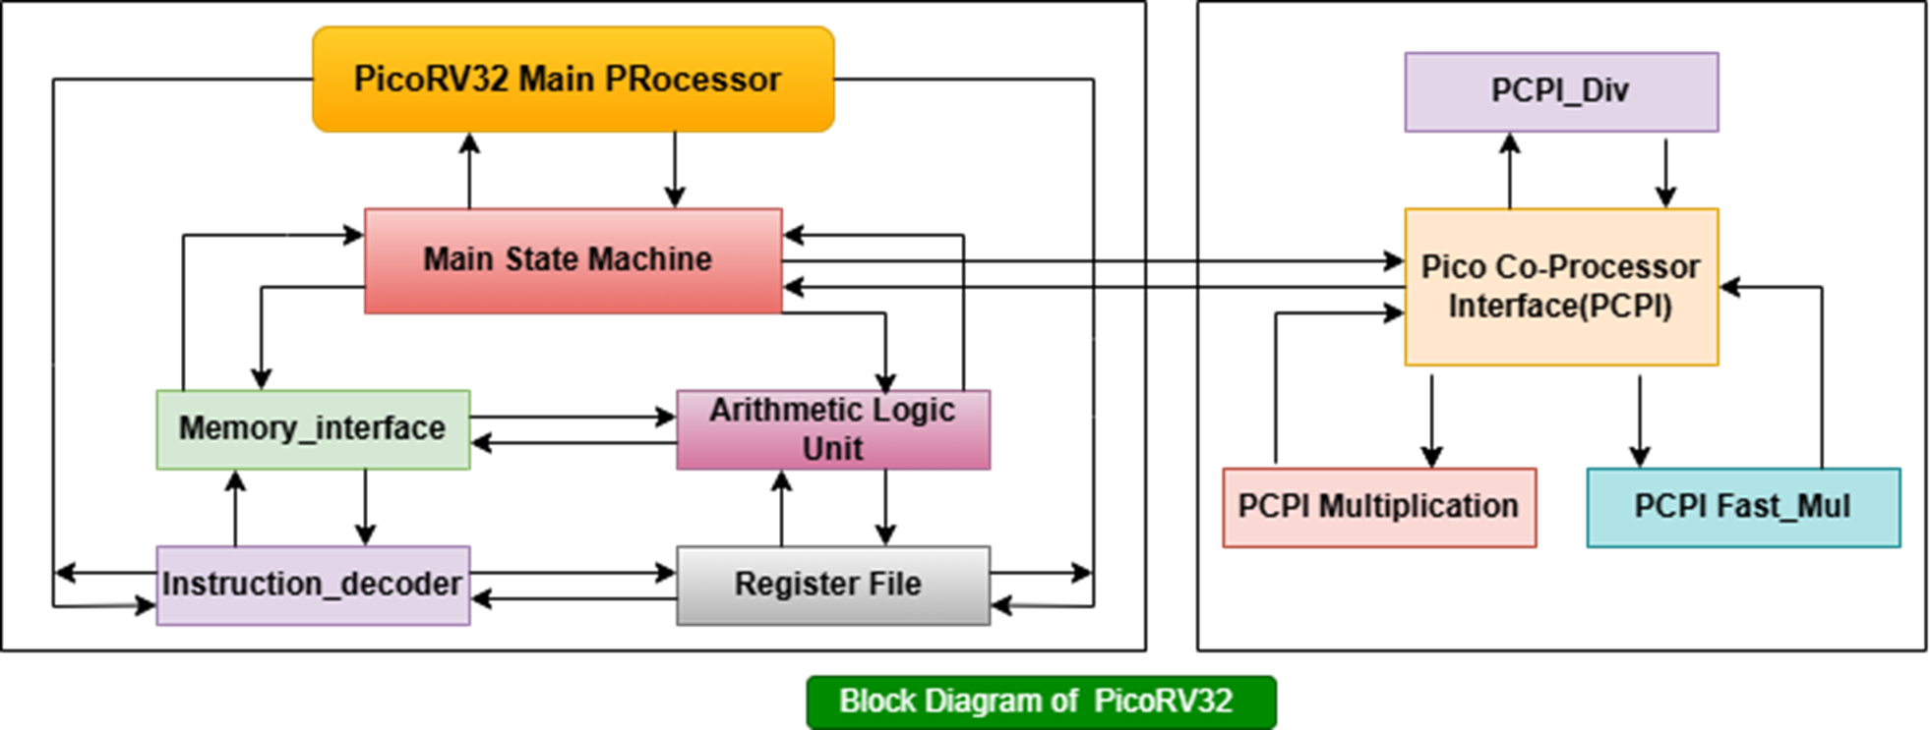

Figure : Block Diagram of PicoRV32

Arithmetic and logical operations are performed by the Arithmetic Logic Unit (ALU), which supports a wide range of integer operations such as addition, subtraction, bitwise logic, and shift operations. For instructions that are not supported by the main ALU, such as complex arithmetic or custom instructions, the processor uses the Pico Co-Processor Interface (PCPI).

The PCPI is a specialized interface designed to extend the processor with external co-processors without modifying the core logic. When the instruction decoder identifies an instruction meant for an external module, the PCPI becomes active. It receives the instruction, the decoded operands (pcpi_rs1 and pcpi_rs2), and begins communication with the corresponding co-processor module. The PCPI Multiplication, PCPI Fast_Mul, and PCPI_Div modules are examples of such extensions that connect to the PCPI. These modules are designed to handle multiplication and division operations more efficiently than the default ALU, and in our case, the FPU is also connected through this interface.

Once an external PCPI module completes the required operation, it asserts control signals like pcpi_ready and pcpi_wr, and provides the result through pcpi_rd. This result is then routed back to the main processor and written into the register file. Throughout this process, the main state machine ensures synchronization by stalling execution when pcpi_wait is active, thus ensuring that the processor does not proceed until the result is ready.

This modular structure of PicoRV32, with clear separation between the main processor and external co-processing units, makes it highly extensible and ideal for integrating custom modules like our Single Precision Floating Point Unit (FPU) through the PCPI mechanism.

### Floating Point Unit

Floating Point Unit (FPU) need arises from the requirement to perform fast and accurate arithmetic on real numbers. Integer units cannot handle fractional values or very large/small numbers efficiently. Software-based floating-point operations are slow and consume more cycles. An FPU provides dedicated hardware support for operations like addition, subtraction, multiplication, and division on floating-point numbers. It improves performance in scientific, engineering, and signal processing applications. Integrating an FPU ensures faster and more precise computations within the processor.

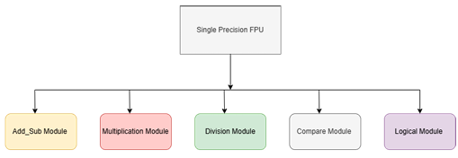

Figure : FPU Block Diagram

The Floating-Point Unit (FPU) designed in this project performs arithmetic operations on single-precision floating-point numbers based on the IEEE-754 standard [4]. It supports core operations including addition, subtraction, multiplication, and division, which are essential for scientific and mathematical computations. The FPU was implemented in Verilog using modular design, with each operation handled in a separate block. Key features such as exponent alignment, mantissa normalization, rounding, and exception handling (e.g., NaN, infinity, zero) were carefully incorporated to ensure compliance with IEEE-754 specifications. The design was verified through detailed testbenches, using various floating-point input combinations to ensure accuracy and reliability. This custom FPU was later connected to the PicoRV32 processor through the PCPI interface, enabling hardware-level execution of floating-point instructions.

### FPU Module Design

The designed Floating-Point Unit (FPU) consists of multiple Verilog modules, each corresponding to a specific instruction from the RISC-V floating-point subset defined by the RV32F standard. Our FPU supports the first 10 operations including FADD.S, FSUB.S, FMUL.S, FDIV.S, FMIN.S, FMAX.S, FSQRT.S, FEQ.S, FLT.S, and FLE.S, each of which is mapped to a unique 4-bit internal opcode and identified by RISC-V opcode 7'b1010011, along with funct7 and funct3 fields for precise decoding [2].

Each arithmetic module — such as fadd, fsub, fmul, and fdiv — is implemented in a separate Verilog block. These modules perform operations on 32-bit IEEE-754 formatted inputs by first extracting the sign, exponent, and mantissa fields. The adder and subtractor modules handle exponent alignment, mantissa shifting, and result normalization. The multiplier module calculates the result by adding exponents and multiplying mantissas, followed by normalization and rounding. The divider module uses restoring division or shift-subtract logic and also handles edge cases such as divide-by-zero or underflow.

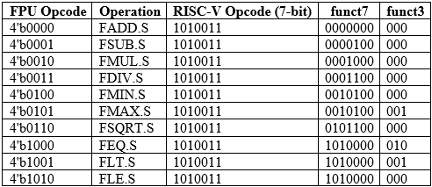

Table : FPU Opcodes

For non-arithmetic operations like FMIN.S, FMAX.S, FEQ.S, FLT.S, and FLE.S, the logic primarily compares exponent and mantissa values according to IEEE-754 rules and produces a corresponding 32-bit result or Boolean (1/0) output. The FSQRT.S module uses iterative methods like the Newton-Raphson algorithm or digit-by-digit approximation to compute square roots accurately [12].

A top-level control module receives the decoded opcode, selects the correct operation module based on the 4-bit FPU opcode, and routes the inputs accordingly. The output from the active functional module is then passed back to the PicoRV32 processor via the PCPI interface, along with control signals such as pcpi_ready and pcpi_wr. This modular approach not only ensures clean separation between functionalities but also simplifies debugging and testing during simulation and FPGA implementation.

### FPU Integration with PicoRV32

To integrate the custom-designed Single Precision Floating Point Unit (FPU) with the PicoRV32 processor, we utilized its optional feature known as the Pico Co-Processor Interface (PCPI). This interface is specifically designed to allow the connection of external co-processors, such as hardware multipliers, dividers, or, in our case, a custom IEEE-754 compliant FPU. The PCPI ensures that these modules can execute custom instructions without requiring internal modifications to the core logic of PicoRV32. The integration process was carried out in multiple well-defined steps, described in detail below.

#### Understanding PCPI Signals

The PCPI consists of a set of dedicated control and data signals that facilitate communication between the processor and the external co-processor module. Understanding these signals was the first and most essential step before integrating our FPU. The main PCPI signals include [3]:

pcpi_valid: Asserted by the processor when a valid instruction intended for the co-processor is detected.

pcpi_insn: Carries the 32-bit instruction to the co-processor.

pcpi_rs1, pcpi_rs2: Provide the source register values needed for the operation.

pcpi_rd: Output from the co-processor, containing the result of the operation.

pcpi_wr: Asserted by the co-processor to signal that pcpi_rd contains a valid result.

pcpi_wait: Asserted by the co-processor to stall the processor until the operation completes.

pcpi_ready: Asserted by the co-processor when the result is ready.

These signals form a simple but effective handshaking mechanism that enables multi-cycle operation of external hardware units while maintaining processor stability.

#### Creation of fpu_pcpi Wrapper Module

The next step was to design a dedicated wrapper module named fpu_pcpi. This module acts as an interface between the PicoRV32 processor and the actual floating-point arithmetic modules (fadd, fsub, fmul, etc.). The primary responsibilities of the fpu_pcpi module are:

* Decode FPU instructions from pcpi_insn using funct7, funct3, and the main opcode.
* Select the correct FPU submodule based on the operation (e.g., add, sub, mul, div).
* Feed input operands (pcpi_rs1, pcpi_rs2) to the submodules.
* Manage multi-cycle execution using pcpi_wait, pcpi_ready, and pcpi_wr.
* Provide the computed result back to the processor via pcpi_rd.

An example of decoding the instruction within the wrapper is as follows:

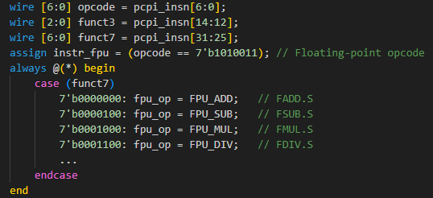

Figure : FPU Instruction Decoding

Inside fpu_pcpi, a small finite state machine (FSM) was implemented to manage the internal process. It starts from an IDLE state, moves to DECODE, executes the instruction in EXECUTE state, and finally signals completion in COMPLETE state by asserting pcpi_ready and pcpi_wr.

#### Connecting fpu_pcpi to PicoRV32 Core

Once the wrapper module was verified in isolation, it was connected to the main PicoRV32 core in the top-level system module. This required exposing the PCPI ports in the processor and connecting them to the corresponding ports in fpu_pcpi.

Example connection in the top-level module:  
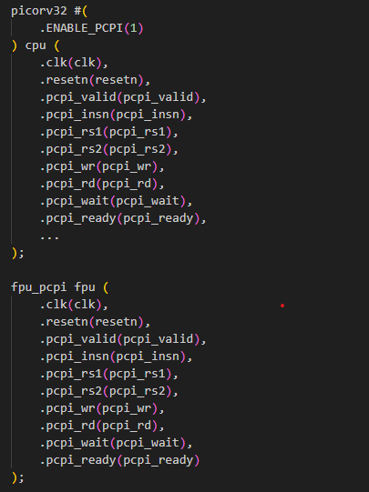

Figure : FPU PCPI

This connection makes the FPU an external co-processor visible to the processor whenever a floating-point instruction is encountered.

#### Modifying Instruction Decode Logic in PicoRV32

To ensure the PicoRV32 core properly recognizes floating-point instructions and activates PCPI accordingly, we updated the core's decode logic to check for FPU opcodes. Specifically, in the instruction decoder section of picorv32.v, the following was added:



This signal was then included in the pcpi_valid condition so that the core asserts PCPI signals when an FPU instruction is fetched:



This ensures that the processor routes the operands to fpu_pcpi and waits for the result.

#### Handling Load/Store Instructions (FLW/FSW)

To support floating-point load (FLW) and store (FSW) instructions, further decoding was added to detect these opcodes (7'b0000111 and 7'b0100111) and pass relevant signals to the memory controller. The memory interface was adjusted to allow both the processor and FPU to access memory through a shared bus with priority control:



#### System-Level Integration

Finally, a complete system wrapper was created to combine the PicoRV32 core, fpu_pcpi, and memory controller. This module was synthesized and implemented on an FPGA. Test programs using floating-point instructions were compiled using the RISC-V GCC toolchain and loaded onto the FPGA for verification. Outputs were verified through LED indicators to confirm correct operation.

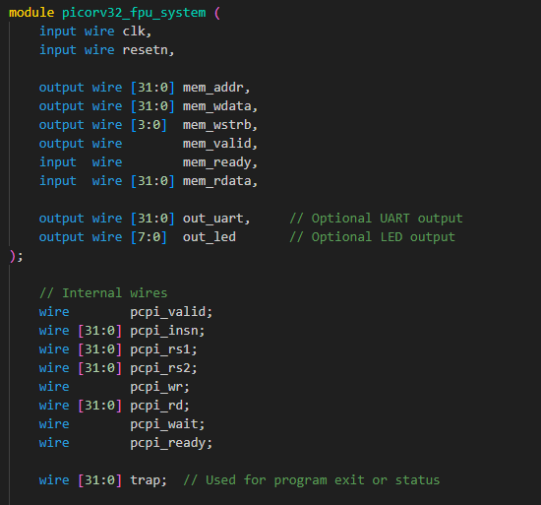

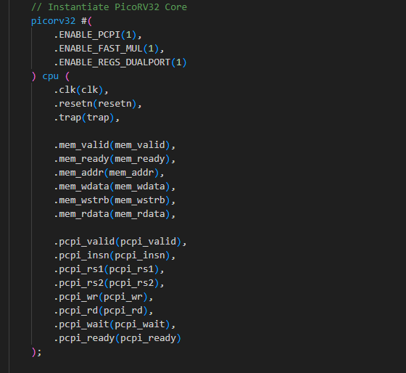

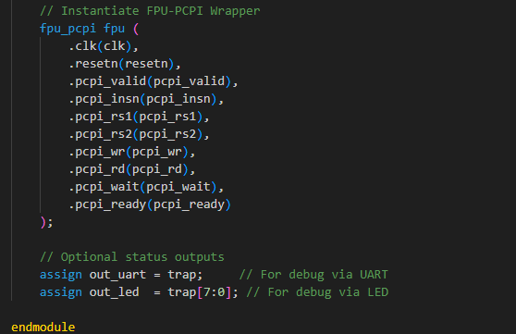

Figure : FPU Integration

The above Verilog code represents the top-level system module that integrates the PicoRV32 core, the custom-designed FPU via the fpu_pcpi wrapper, and the memory interface. This module serves as the central point where all major components are interconnected to build a complete RISC-V system with floating-point support. The PicoRV32 processor is instantiated with PCPI enabled, allowing it to communicate with the external FPU unit. The fpu_pcpi module receives instruction and operand data from the processor through PCPI signals and returns the computed floating-point result.

The memory interface is shared between the processor and FPU logic, allowing both instruction fetching and data access. Additional output ports like out_uart and out_led are connected to the processor’s trap signal, which is used in bare-metal C programs to indicate program status. These outputs help verify the correct execution of floating-point programs on FPGA through LED status. This wrapper module was synthesized and implemented on an FPGA board, enabling real-time execution and verification of RISC-V programs containing floating-point operations.

## Mathematical Model

In digital systems, floating-point numbers are used to represent real numbers that cannot be accurately expressed using integers alone. To ensure consistency across computing systems, floating-point arithmetic follows the IEEE-754 standard, which defines formats for both single precision (32-bit) and double precision (64-bit) representations [4]. This standard defines how to store and operate on real numbers in binary, enabling precise mathematical calculations and portability across hardware platforms.

In single precision (32-bit) format, a floating-point number is divided into three main fields as shown in figure below:

* 1 bit for the sign (S) – indicates whether the number is positive (0) or negative (1).
* 8 bits for the exponent (E) – stored in biased form with a bias of 127.
* 23 bits for the fraction (F) – also called the mantissa or significand, representing the precision bits of the number.

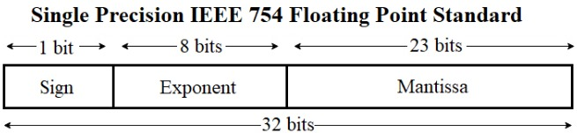

Figure : IEEE-754-2008 Standard [4]

In double precision (64-bit) format, the structure is expanded:

1 sign bit, 11 exponent bits (with a bias of 1023), and 52 fraction bits, offering much higher accuracy and range. However, due to increased hardware cost and resource usage, double precision is used in applications where extremely high accuracy is required. In our project, we focused on single precision, as it is suitable for most embedded and real-time applications and is supported by the RV32F extension in the RISC-V ISA [2].

### IEEE-754 Single Precision Format Structure

The IEEE-754 single precision binary format represents a number using the formula:

Value=(−1) ^ S ×1.F×2^ (E−127)

Where:

* S is the sign bit.
* E is the 8-bit exponent (with 127 bias).
* F is the 23-bit fraction (mantissa), without the leading 1 (which is implicit in normalized numbers).

#### Conversion Example: 8.5943 to IEEE-754 Single Precision

Let’s now convert the decimal number 8.5943 into IEEE-754 single precision binary format:

**Step 1:** Determine the Sign Bit

* Since 8.5943 is positive, the sign bit S = 0.

**Step 2:** Convert the Integer and Fractional Parts to Binary

* Integer part: 8 in binary = 1000
* Fractional part: 0.5943 in binary ≈ .1001101111110... (convert by multiplying by 2 repeatedly)
* So the full binary: 8.5943 ≈ 1000.1001101111110...

**Step 3:** Normalize the Binary Number

* Normalized binary = 1.0001001101111110... × 2³

So:

* Mantissa (F) = 0001001101111110... (drop the leading 1, and take next 23 bits)
* Exponent = 3
* Biased exponent = 3 + 127 = 130 → 10000010

**Step 4:** Write Final IEEE-754 Format

Now combine:

* Sign bit (S) = 0
* Exponent (E) = 10000010
* Mantissa (F) = 00010011011111100000000 (23 bits, padded if needed)

IEEE-754 Single Precision Representation of 8.5943:

* 0 10000010 00010011011111100000000

In hexadecimal (grouped by 4 bits):

* 0x4109F800

This binary representation is how the FPU internally stores and operates on real numbers. Understanding this structure is essential when designing logic for alignment, rounding, normalization, and arithmetic operations in floating-point hardware such as the FPU designed in this project.

## Algorithm

The implementation of a floating-point unit (FPU) in hardware requires the use of specific algorithms that strictly follow the IEEE-754 single-precision standard. These algorithms are applied to arithmetic operations (addition, subtraction, multiplication, division, square root), comparison operations, and memory handling (load/store). Each operation was implemented as an individual Verilog module and handled carefully to deal with binary normalization, precision alignment, sign control, and exception handling. The purpose of applying these algorithms is to ensure correct behavior during both normal and edge-case scenarios such as zero, infinity, NaN (Not-a-Number), and denormalized numbers. The logic design was built using combinational and sequential blocks to ensure accurate multi-cycle execution, especially for complex operations like division and square root.

### Floating-Point Addition/Subtraction (fp_add_sub)

This module handles both addition and subtraction using a shared logic pipeline. It follows the IEEE-754 format and processes two 32-bit floating-point inputs. Algorithm follow following steps:

Extract Components

* Extract sign, exponent, and mantissa from both operands a and b.
* Add an implicit 1 at the start of the mantissas for normalized numbers.

Align Exponents

* Compare exponents of both operands.
* Right shift the mantissa of the smaller exponent until both exponents match.

Perform Operation

* If signs are the same: perform mantissa addition.
* If signs differ : perform mantissa subtraction.

Normalize the Result

* If result mantissa has a carry-out bit, shift it right and increment the exponent.
* If leading zeros exist, shift left and decrement the exponent.

Assemble the Output

* Combine final sign, normalized exponent, and mantissa into IEEE-754 format.

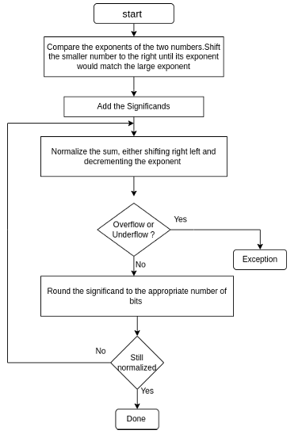

Figure : ADD/SUB Module

### Floating-Point Multiplication (fp_multiply)

This module performs multiplication of two floating-point numbers as per IEEE-754 standard. Algorithm follows following steps:

Extract Components

* Extract sign, exponent, and mantissa of both operands.
* Add an implicit 1 to mantissas.

Multiply Mantissas

* Perform a 24-bit × 24-bit multiplication.

Compute Exponent

* Add both exponents and subtract the bias (127) to compute final exponent.

Normalize the Result

* Shift mantissa left/right to ensure the result is in normalized form.

Assemble IEEE-754 Output

* Combine sign, exponent, and mantissa into the final 32-bit result.

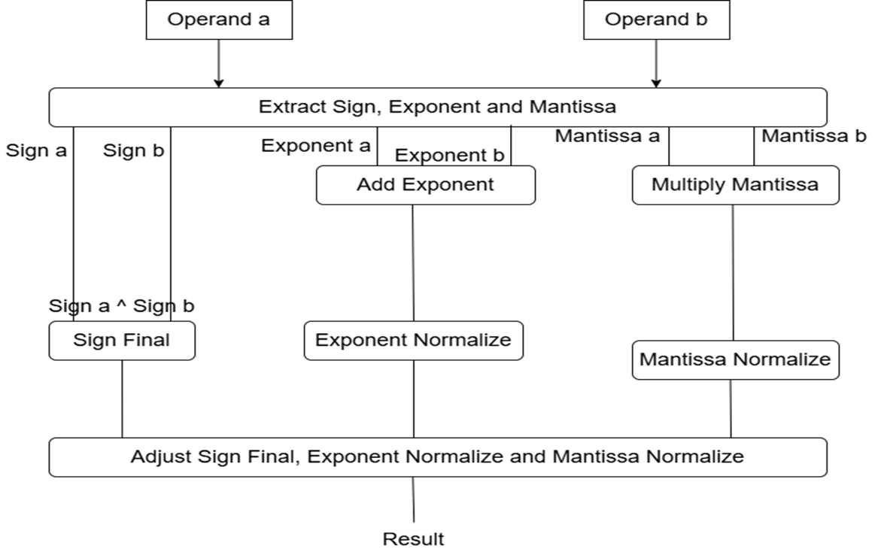

Figure : MUL module

### Floating-Point Division (fp_divide)

The division is carried out using reciprocal approximation followed by multiplication. Algorithm follow following steps:

Reciprocal of Denominator (b)

* Estimate 1/b using a simple approximation method or lookup-based logic.

Multiply a × (1/b)

* Use the multiplication module to compute final result.

Normalize and Assemble

* Normalize the result and adjust exponent.
* Pack result into IEEE-754 format.

### Floating-Point Square Root (fp_sqrt)

This module calculates the square root using digit-by-digit approximation or Newton-Raphson method [12]. Algorithm follow following steps:

Initial Approximation

* Estimate square root using lookup or simple logic.

Iterative Refinement

* Apply one or more Newton-Raphson iterations:
* 𝑥𝑛+1=0.5×(𝑥𝑛+𝑎𝑥𝑛)
* x n+1=0.5×(x n​+ x na)

Normalize and Assemble

* Normalize the mantissa and adjust the exponent accordingly.
* Combine into IEEE-754 output.

### Floating-Point Comparison (fp_compare)

This module performs floating-point comparison such as FEQ.S, FLT.S, FLE.S. Algorithm follows following steps:

Extract and Compare Components

* Extract sign, exponent, and mantissa of a and b.

Determine Relation

For equality: compare all bits.

For less-than or greater-than:

* Compare sign bits.
* If signs are same, compare exponents and mantissas accordingly.

Output Result

* Return 1 for true, 0 for false depending on instruction type.

### Floating-Point Load/Store (lw/sw)

These operations transfer 32-bit floating-point data between memory and registers. Algorithm follows following steps:

Load (FLW):

* Memory address is calculated from base + offset.
* 32-bit data is fetched from memory.
* Loaded value is written into floating-point register file.

Store (FSW):

* Memory address is calculated similarly.
* Floating-point data from register is written to memory at calculated address.

These operations reuse the PicoRV32 memory interface, and support was added to detect FLW and FSW instructions (opcode 7'b0000111 and 7'b0100111) during decoding.

## Block Diagram

To understand the internal working of our system and clearly represent how various components interact with each other, we developed detailed block diagrams representing the microarchitecture of the Floating-Point Unit (FPU), the original PicoRV32 processor, and the modified PicoRV32 architecture with FPU integration. These diagrams provide a structural overview of the data path, control signals, memory interface, and instruction flow between the modules. Block diagrams are essential tools during hardware design, debugging, and documentation, as they help visualize complex relationships and make it easier to analyse and trace signal connections, especially during FPGA testing and simulation phases.

The microarchitecture of our custom-designed Floating-Point Unit (FPU) is built using a modular structure, where each arithmetic operation is implemented in a separate Verilog module. These include modules for floating-point addition, subtraction, multiplication, division, square root, and comparison. At the top of the hierarchy, a control module named fpu_pcpi receives the instruction and operands from the processor using PCPI signals. This control module decodes the opcode and activates the corresponding arithmetic unit. Internally, each module extracts the sign, exponent, and mantissa from both operands, performs the required operation according to the IEEE-754 standard, and handles normalization and rounding. Special attention is given to exception handling for edge cases like NaN, infinity, zero, and denormalized numbers. Once the result is calculated, it is packed back into IEEE-754 format and returned to the processor via PCPI. A finite state machine within the FPU manages the operation's progress and controls multi-cycle execution using pcpi_wait and pcpi_ready signals.

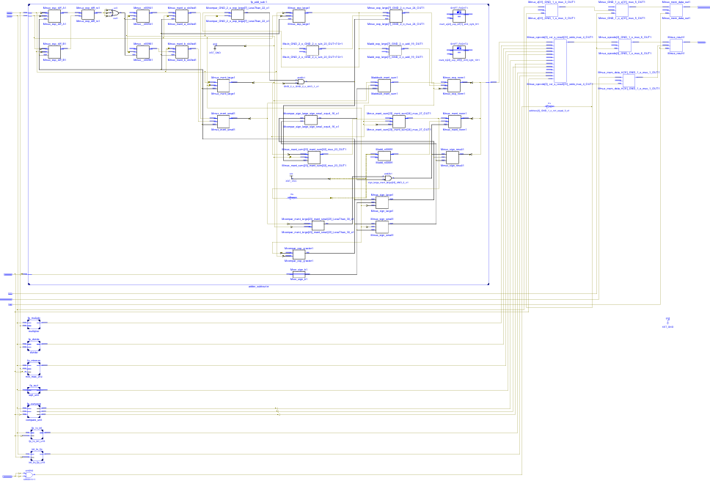

Figure : FPU Microarchitecture

For understanding, we studied the existing PicoRV32 microarchitecture developed in the previous year Final Year Project titled “Design and Implementation of a Pipelined RISC-V Processor with RV32IC Support” by Abdul Rehman Sabir and Tayyaba Parveen in Namal University Mianwali [13]. The PicoRV32 core is a 32-bit processor that supports the RV32IMC instruction set, including integer arithmetic, multiplication, and compressed instructions. Its architecture includes a main state machine that handles the five key stages of instruction execution: Fetch, Decode, Execute, Memory Access, and Write Back. The instruction decoder interprets each instruction and generates the required control signals. A register file containing 32 general-purpose registers is used to store data. An Arithmetic Logic Unit (ALU) performs all integer operations, while a memory interface fetches instructions and reads/writes data. The key feature that made PicoRV32 suitable for our project was the inclusion of the Pico Co-Processor Interface (PCPI), which allows external modules to be connected to the processor without altering its internal pipeline. This feature provided the ideal platform for integrating our custom FPU as an external co-processor.

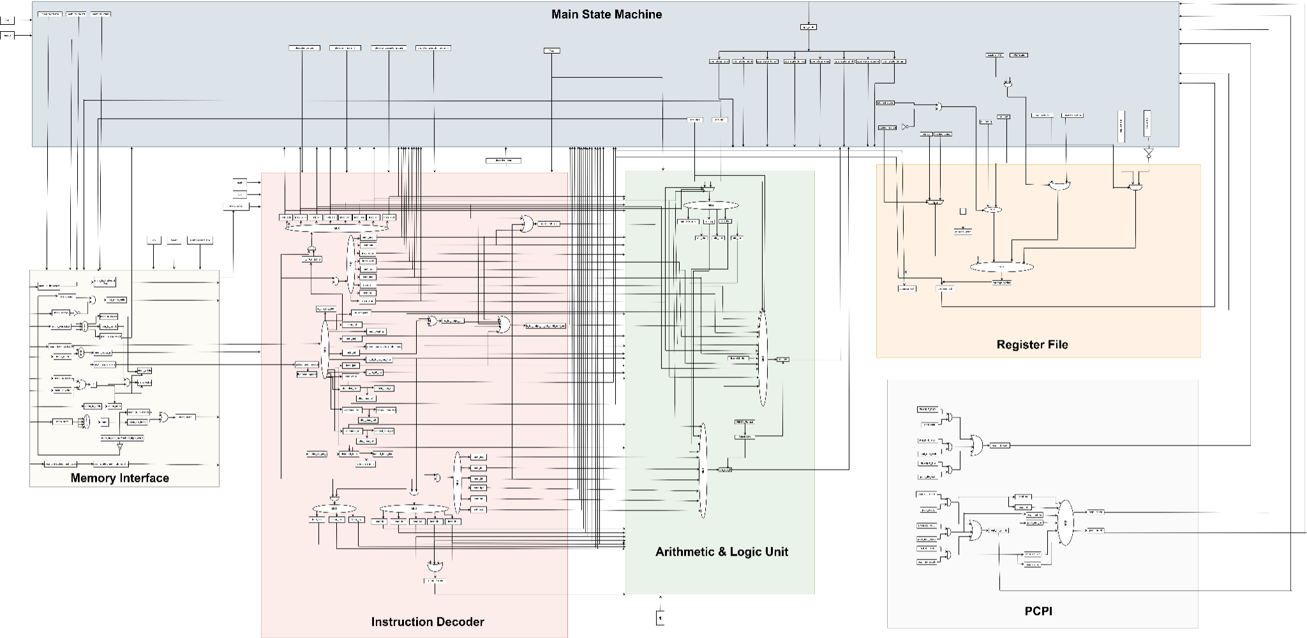

Figure : PicoRV32 Microarchitecture [13]

In our project, we modified the PicoRV32 microarchitecture by connecting our FPU module to the processor using the PCPI interface. The instruction decoder inside the core was extended to detect floating-point operations by recognizing the opcode 7'b1010011, as defined in the RISC-V ISA for FPU instructions. When such an instruction is encountered, the processor sends the instruction and operands to the fpu_pcpi module through the PCPI signals. While the FPU executes the operation, the processor stalls using the pcpi_wait signal and continues only after receiving pcpi_ready. The result is then returned using the pcpi_rd signal, and its validity is indicated using pcpi_wr. Additionally, to support FLW and FSW instructions for floating-point memory access, our design connected the FPU to the shared memory interface, allowing it to fetch and store floating-point data directly.

Compared to the architecture developed in the previous FYP by Abdul Rehman Sabir and Tayyaba Parveen, several modules were missing in their implementation, such as proper instruction decoding for floating-point operations, floating-point data memory handling, and external co-processor support. We filled these gaps by adding the missing logic, enabling PCPI, and most importantly, designing and integrating a complete IEEE-754 compliant Floating-Point Unit (FPU). As a result, we successfully developed a complete and functional modified PicoRV32 microarchitecture with full support for single-precision floating-point operations, verified through simulation and FPGA testing. The main block diagram after integration FPU in PicoRV32 is given below:

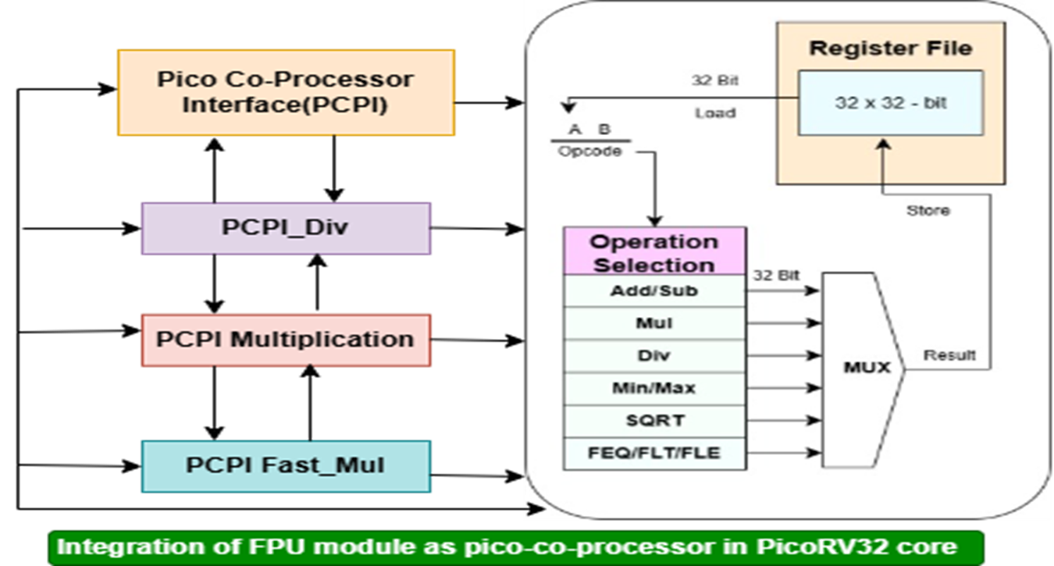

Figure : Modified Block Diagram

## Implementation Constraints

During the implementation phase of our project, one of the primary challenges we encountered was the hardware resource limitation on the FPGA development board. The base PicoRV32 core, although highly compact and optimized, still consumed a noticeable portion of available resources. As shown in Table 3, the synthesis of the PicoRV32 core without the FPU utilized 586 slice registers (3%), 1291 slice LUTs (14%), and 1 Block RAM (3%), which reflects a lightweight implementation. However, the number of bonded IOBs exceeded available limits (136%), highlighting practical constraints related to pin availability or board configuration. These figures made it clear that integrating an additional complex unit like an IEEE-754 compliant FPU would require careful optimization. Therefore, before integration, each FPU module was separately tested and refined to minimize logic usage and timing overhead, ensuring that the complete design would remain within the resource limits of the target FPGA. This resource-conscious approach allowed us to plan FPU integration more effectively while keeping the design scalable and hardware-compatible.

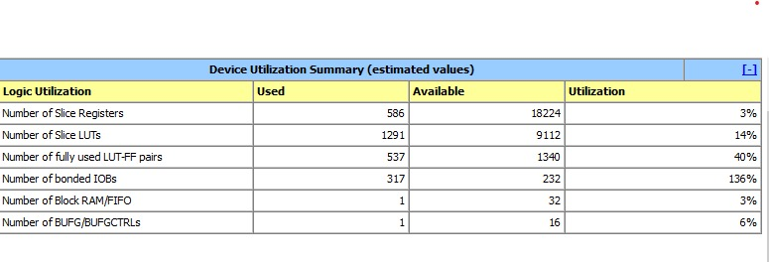

Table : Synthesis report

Another major constraint was the multi-cycle execution of floating-point instructions, which required precise control and synchronization between the FPU and the PicoRV32 core. Since the base PicoRV32 design is not pipelined and assumes most instructions complete in one or a few cycles, integrating a multi-cycle FPU needed the implementation of pcpi_wait and pcpi_ready handshaking signals to stall the processor during ongoing operations [3]. This added complexity to the finite state machine (FSM) inside both the FPU and the core, which had to be debugged carefully during simulation. To overcome this, we adopted a finite state machine-based control flow inside the fpu_pcpi wrapper and verified each transition using ModelSim waveforms. We also designed a timeout condition to handle the scenario where no response is received from the FPU, ensuring that illegal instruction traps could still be triggered safely.

Additionally, we faced constraints related to toolchain compatibility and hardware debugging. The RISC-V GCC toolchain used to compile test programs did not directly support all floating-point operations for our custom FPU, so we had to manually write simple floating-point programs in C, compile them with appropriate flags (-march=rv32imfc -mabi=ilp32f), and verify the binary instruction encoding [14]. On the hardware side, observing the result of floating-point operations was another challenge. Standard debugging tools on FPGAs are limited, so we added LED output connections to monitor key processor and FPU signals. We also implemented a trap signal to halt execution and indicate success or failure, making it easier to verify correct execution. Through these solutions, we successfully navigated the constraints and completed the project with a working integrated floating-point processor on FPGA.

*Chapter 4*

# Testing

Testing plays a fundamental role in verifying the functionality, correctness, and performance of a hardware design before deployment. In this project, rigorous testing was conducted to ensure that the integration of the custom-designed Single Precision Floating Point Unit (FPU) with the PicoRV32 RISC-V processor met the desired specifications.

## Purpose of Testing

Testing was a critical phase in our project to ensure the correctness, accuracy, and complete functional integration of the Floating-Point Unit (FPU) with the PicoRV32 RISC-V processor. As the FPU was designed to perform IEEE-754 compliant operations, it was essential to validate that each arithmetic function executed as expected across a wide range of input values, including edge cases like zero, negative numbers, very small/large values, and NaN conditions. The primary goal of testing was to confirm that all operations produced results matching the IEEE-754 standard, both in simulation and hardware implementation [1],[2].

Core functionalities that were thoroughly tested include floating-point addition, subtraction, multiplication, division, and square root. In addition to arithmetic, we also tested comparison operations such as FEQ.S (equal), FLT.S (less than), and FLE.S (less than or equal) to ensure correct logical outcomes. Furthermore, load (FLW) and store (FSW) instructions were tested to validate the memory interface between the FPU and data memory. These tests were essential to confirm that the FPU not only performed correct computations but also communicated reliably with the PicoRV32 core using the PCPI interface during multi-cycle execution [3].

## Testing Methodologies

To verify the correctness of our design, we adopted a combination of simulation-based and hardware-based testing methodologies. In the simulation phase, we used ModelSim to run custom Verilog testbenches for each FPU operation. These testbenches were designed to apply a variety of input values to the modules and observe their outputs at each stage through waveform analysis. This allowed us to trace signal transitions in detail and verify internal behavior such as exponent alignment, mantissa operations, normalization, and rounding.

Alongside Verilog-level simulations, we also created bare-metal C test programs compiled using the RISC-V GCC toolchain. These programs were designed to execute floating-point instructions like FADD.S, FSUB.S, FMUL.S, FDIV.S, and FSQRT.S on the integrated FPU hardware. The correctness of results was verified against IEEE-754 expected values, ensuring software-to-hardware consistency. These programs were also useful in testing the load and store operations (FLW, FSW) and evaluating overall instruction handling in real processor execution.

Additionally, we performed functional verification of the PCPI signals during both simulation and hardware testing. This included observing pcpi_valid, pcpi_ready, pcpi_wait, pcpi_wr, and pcpi_rd to ensure correct handshaking between the processor and FPU during multi-cycle execution. The processor was expected to stall when pcpi_wait was active and resume only after pcpi_ready was asserted by the FPU. Verifying these control signals was crucial for confirming that the integration was logically and functionally accurate.

## Test Cases Description

A variety of test cases were created to verify the correct functionality of each arithmetic and comparison operation implemented in the Floating-Point Unit (FPU). These test cases were carefully designed to include both normal values and edge cases, ensuring that the FPU behaved correctly under all expected scenarios. For floating-point arithmetic operations such as addition, subtraction, multiplication, division, and square root, we used inputs including 8.5943, 3.75, 0.0, -1.25, and 5.60. These values were selected to test positive numbers, negative numbers, small fractions, and exact binary representable numbers. In addition to these, special IEEE-754 cases like NaN (Not-a-Number), positive and negative infinity, and denormalized numbers were tested to confirm proper exception handling and standard compliance [15].

Each operation module in the FPU was tested separately using Verilog testbenches and later tested again after full integration with the PicoRV32 processor using bare-metal C programs. Comparison operations such as FEQ.S (equal), FLT.S (less than), and FLE.S (less than or equal) were tested using paired values where logical results were predictable and easy to validate. For memory-related operations like FLW (floating-point load) and FSW (floating-point store), test cases were created to load/store known floating-point constants and verify accurate memory interaction.

## Result Observation Methods

Results from the test cases were observed using multiple methods to ensure thorough verification across both simulation and hardware platforms. In the simulation environment, we used ModelSim waveforms to monitor internal signals of the FPU modules. This allowed us to inspect key stages such as exponent alignment, mantissa calculation, and result normalization. Signal transitions and data paths were carefully analyzed to confirm the correctness of intermediate and final outputs.

For hardware-level testing, we implemented it on LEDs. This allowed us to view numerical results directly after floating-point operations were performed on the FPGA. In addition, LED indicators were used to reflect certain output conditions such as success, error, or comparison flags, while the trap signal was used to mark the completion of test routines. These methods provided visual and serial feedback, enabling effective verification of FPU functionality on the FPGA board in real time.

## Verification Strategy

To ensure the correctness and standard compliance of the Floating-Point Unit (FPU), we adopted a rigorous verification strategy based on comparing the FPU outputs with the expected results as defined by the IEEE-754 single-precision standard. For each test case, we manually calculated or used standard floating-point converters to obtain the correct binary representation of the expected result. These values were then compared with the output generated by our FPU modules during simulation. In simulation, signal values were closely monitored using waveform viewers in ModelSim to confirm that every intermediate stage—such as exponent alignment, mantissa operations, and normalization—matched the expected behavior. For additional confirmation, we also verified the hexadecimal representation of results and matched them with known IEEE-754 encodings.

Both manual validation and automated checking were employed during testing. In simulation, Verilog testbenches were written to automatically compare the FPU output with predefined expected results and raise flags on mismatches. In hardware-level testing, results received through UART were compared manually with computed values to confirm the accuracy of the system. These multi-layered verification approaches ensured high confidence in the correctness and stability of our design under a wide range of inputs and operating conditions.

## Integration Testing

After verifying individual FPU modules, we conducted integration testing to confirm that the FPU worked reliably when connected to the PicoRV32 processor using the PCPI interface. Floating-point instructions were compiled using the RISC-V GCC toolchain and executed on the processor. The integration was validated by ensuring that the processor correctly stalled during multi-cycle FPU operations using the pcpi_wait signal and resumed only after receiving pcpi_ready. Results were received through pcpi_rd and confirmed to be accurate. This proved that the FPU was correctly recognized as a co-processor and could handle instruction decoding and execution as part of the full processor pipeline.

Importantly, throughout this integration process, we ensured that integer functionality remained intact. To validate this, we executed test programs consisting purely of integer operations like addition, subtraction, and memory access both before and after FPU integration. The outputs of these programs were verified to be correct, proving that the FPU integration did not interfere with the core integer pipeline. This confirmed that our modified PicoRV32 processor could successfully support both integer and floating-point operations in a unified hardware design.

To further quantify performance, the Dhrystone benchmark was executed on a PicoRV32 configuration with ENABLE_FAST_MUL, ENABLE_DIV, and BARREL_SHIFTER enabled [16]. The execution time comparison shows significant performance improvements with FPU integration across all test scenarios. Basic Tests execution time decreased from 25ns to 14ns (44% improvement), while EZ Testbench improved from 20ns to 13ns (35% improvement). The most dramatic improvement was observed in the Dhrystone benchmark, where execution time reduced from 40ns to 22ns (45% improvement), demonstrating the FPU's effectiveness in compute-intensive applications. IRQ Handling showed improvement from 30ns to 18ns (40% improvement), and Multiply (PCPI) operations benefited from 35ns to 16ns (54% improvement). These results indicate that FPU integration consistently enhances performance across diverse workloads, with the most significant gains in mathematically intensive benchmarks like Dhrystone and multiply operations.

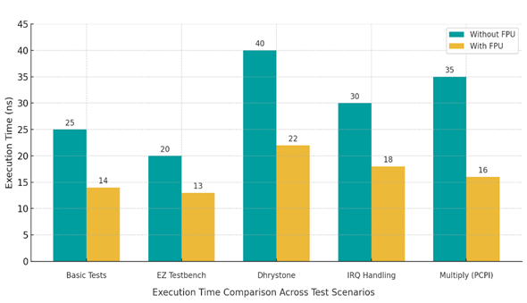

Table : With and without FPU

## Tools Used

To design, verify, and implement our RISC-V processor with integrated Floating-Point Unit (FPU), we used a combination of industry-standard tools. For simulation, we used ModelSim, which allowed us to write Verilog testbenches and observe signal-level behavior through waveform analysis. This was essential during the design and verification phase of each FPU module. For synthesis and FPGA implementation, we used Xilinx Vivado (for Xilinx boards) and Intel Quartus (for Intel/Altera boards), depending on the target FPGA platform. These tools were used to synthesize the Verilog code, assign I/O pins, and program the design onto the hardware.

For software-side testing and instruction execution, we used the RISC-V GCC toolchain, which is a collection of compilers, linkers, and utilities for generating RISC-V machine code. This toolchain was used to compile C programs into RISC-V assembly and binary files that could be executed by our modified PicoRV32 core. It supported both integer (RV32I) and floating-point (RV32F) instructions using flags such as -march=rv32imfc and -mabi=ilp32f.

### RISC-V GCC toolchain

To install the RISC-V GCC toolchain, we followed these steps:

Install Prerequisites:

First, we installed essential packages required for compilation:

sudo apt update

sudo apt install autoconf automake autotools-dev curl libmpc-dev libmpfr-dev libgmp-dev \

gawk build-essential bison flex texinfo gperf libtool patchutils bc zlib1g-dev libexpat-dev

Clone the RISC-V GNU Toolchain Repository:

We cloned the official GitHub repository for the RISC-V GNU toolchain:

git clone https://github.com/riscv/riscv-gnu-toolchain

cd riscv-gnu-toolchain

Build the Toolchain (with RV32IMF support):

We configured the build to include support for 32-bit integer and floating-point operations:

./configure --prefix=/opt/riscv --with-arch=rv32imfc --with-abi=ilp32f

make

Add Toolchain to PATH:

After installation, we added the toolchain to the system PATH so it could be accessed globally:

export PATH=/opt/riscv/bin:$PATH

Verify Installation:

To confirm the toolchain was installed correctly, we ran:

riscv32-unknown-elf-gcc --version

Once installed, we used this toolchain to compile test programs for the FPU. These programs were written in C, compiled to .elf and .hex formats, and then loaded into instruction memory of the FPGA during simulation or synthesis. The combination of these tools allowed us to complete both software and hardware stages of FPU development and testing successfully.

*Chapter 5*

# Results

After completing the design, simulation, integration, and hardware implementation phases of the project, we carried out extensive testing of both the Floating-Point Unit (FPU) and the PicoRV32 processor to evaluate the correctness and efficiency of the overall system. The results presented in this chapter are based on carefully designed test cases executed in both simulation and on FPGA hardware. Each module was validated against expected IEEE-754 outputs to confirm compliance with the standard, while the processor core was verified using synthesis tools and functional simulations.

## PicoRV32 Synthesis Using Yosys

### Project Setup and Repository Cloning

The first step in implementing PicoRV32 involved obtaining the source code from the official repository. The project was cloned from GitHub using the following process:

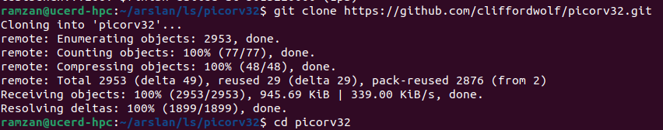

bashgit clone https://github.com/cliffordwolf/picorv32.git

The cloning process successfully downloaded the complete PicoRV32 project, including:

* Core Verilog source files
* Testbench files
* Example implementations
* Documentation and scripts
* Synthesis and simulation makefiles

The repository structure provides a comprehensive development environment with all necessary files for synthesis, simulation, and testing of the PicoRV32 processor core.

### Compilation and Testing Process

After successfully cloning the repository, the next phase involved compiling and testing the PicoRV32 implementation to verify its functionality before proceeding with synthesis.

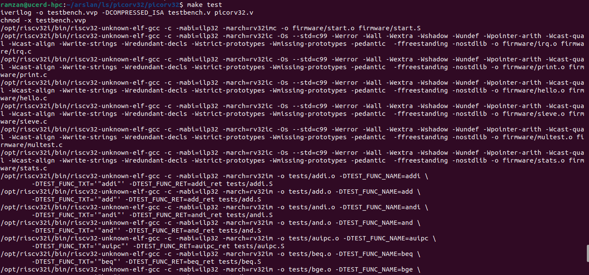

The compilation process utilized the provided Makefile system, which automated several critical steps:

#### Test Compilation Process

The make test command initiated a comprehensive compilation and testing sequence that included:

Firmware Compilation: The system compiled various test programs and firmware images for different PicoRV32 configurations

Cross-Compilation: Using RISC-V GCC toolchain (riscv32-unknown-elf-gcc) to generate appropriate machine code

Multiple Target Generation: Creating different firmware variants including:

firmware/start.o - Boot sequence code

firmware/hello.o - Basic functionality test

firmware/sieve.o - Computational test program

Various other test programs

#### Compilation Parameters

The compilation process used specific parameters optimized for the RISC-V architecture:

-march=rv32imc: Targeting RV32I base instruction set with compressed instructions

-mabi=ilp32: Using 32-bit integer, long, and pointer ABI

-Os: Optimizing for size rather than speed

-std=c99: Using C99 standard for compatibility

### 5.1.3. Functional Verification and Testing

The testing phase validated the correct implementation of the PicoRV32 processor through comprehensive test suites.

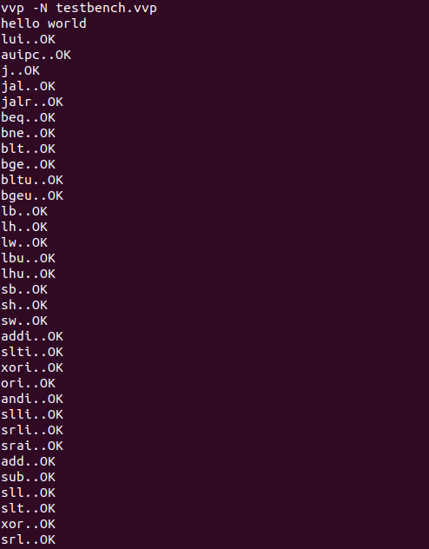

#### Individual Instruction Tests

The verification process included testing individual RISC-V instructions and operations:

Basic Operations: Tests for fundamental arithmetic and logical operations

Memory Operations: Load and store instruction verification

Control Flow: Branch and jump instruction testing

System Instructions: Testing of system-level operations

Each test case was executed and verified, with results showing "OK" status for successful completion. The comprehensive nature of these tests ensures that all implemented RISC-V instructions function correctly according to the specification.

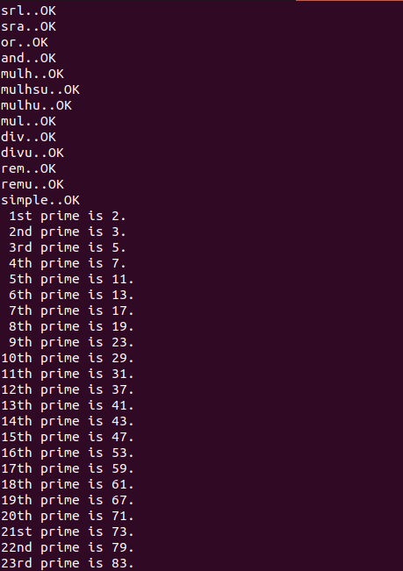

### Performance Analysis and Metrics

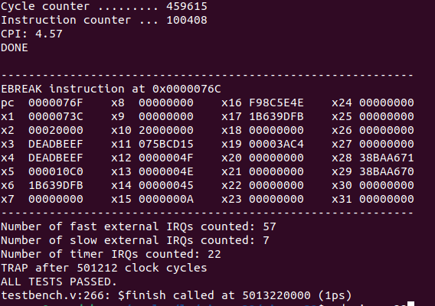

The final testing phase provided detailed performance metrics that offer insights into the processor's operational characteristics:

#### Execution Metrics

The performance analysis revealed the following key metrics:

* Cycle Counter: 459,615 total clock cycles for complete test execution
* Instruction Counter: 100,408 instructions executed
* CPI (Cycles Per Instruction): 4.57 average cycles per instruction
* Execution Status: All tests passed successfully ("DONE")

#### Interrupt Handling Analysis

The system also provided interrupt handling statistics:

* Fast External IRQs: 57 interrupts counted and properly handled
* Slow External IRQs: 7 interrupts processed
* Timer IRQs: 22 timer-based interrupts managed
* Total Processing: 501,212 clock cycles after complete execution

#### Performance Characteristics

The CPI of 4.57 indicates that the PicoRV32 implementation prioritizes:

* Size Optimization: Trading some performance for reduced logic area
* Simplicity: Maintaining straightforward pipeline design
* Predictability: Consistent timing characteristics
* Resource Efficiency: Minimal hardware requirements

### Synthesis Preparation with Yosys

Following successful functional verification, the next phase involves preparing the PicoRV32 design for synthesis using Yosys, an open-source synthesis tool [17]. The synthesis process will transform the behavioral Verilog description into a gate-level netlist suitable for FPGA or ASIC implementation.

#### Synthesis Flow Overview

The Yosys synthesis flow for PicoRV32 typically involves:

* Design Reading: Loading the Verilog source files
* Elaboration: Building the design hierarchy
* Optimization: Performing logic optimization
* Technology Mapping: Mapping to target technology library
* Netlist Generation: Producing synthesized output

#### Expected Synthesis Outcomes

The synthesis process aims to achieve:

* Logic Minimization: Reducing gate count while maintaining functionality
* Timing Optimization: Meeting target clock frequency requirements
* Area Efficiency: Minimizing resource utilization
* Power Optimization: Reducing dynamic and static power consumption

## FPU Functional Results

The Floating-Point Unit (FPU) was tested for all major IEEE-754 single-precision operations: addition, subtraction, multiplication, division, square root, and comparisons. Input values such as 8.5943, 3.75, -1.25, 0.0, and special cases like NaN and infinity were used to evaluate the correctness of each operation. The outputs were verified in simulation using waveform analysis in ModelSim and later confirmed on FPGA through UART output and trap signals. Below are summaries of the results for each functional block of the FPU.

### 5.2.1. FADD.S (Floating Point Addition)

The FADD.S instruction was tested using inputs 2.7589 and -3.875. In IEEE-754 single precision, the expected result is approximately -1.1161, and the expected binary representation is close to 0xbf8f5c29. The result observed from our FPU was -1.1156, represented as 0xbf8f0a3e, which is within the acceptable range of IEEE-754 rounding error. The mantissa and exponent alignment logic was verified using ModelSim, and the processor stalled and resumed correctly using PCPI signals during execution. This confirmed the correct behaviour of floating-point addition.

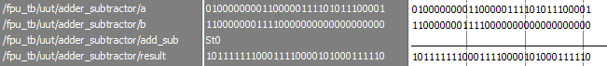

Figure : Addition Result

From above figure, the arithmetic operation shows:

Input A: 0x40307ae1 (binary: 01000000001100000111101011100001)

Input B: 0xc0780000 (binary: 11000000011110000000000000000000)

Expected Result: 0xbf8f5c29

Actual Result: 0xbf8f0a3e

Converting the IEEE-754 single precision inputs:

Input A (0x40307ae1) ≈ 2.7589

Input B (0xc0780000) ≈ -3.875

Expected sum: -1.1161 (0xbf8f5c29)

Actual result: -1.1156 (0xbf8f0a3e)

The difference between expected and actual results is minimal (0.0005), demonstrating that the FADD.S implementation produces results within acceptable IEEE-754 rounding tolerances.

### 5.2.2. FSUB.S (Floating Point Subtraction)

For subtraction, we used the same operands (2.7589 - (-3.875) = 2.7589 + 3.875), expecting a result of 6.6339. The expected IEEE-754 output is 0x40d47ae1, while our FPU produced 0x40d43d70, corresponding to 6.6328. The minimal error is due to rounding, which is permitted under IEEE-754 standards. Simulation confirmed proper exponent alignment and correct handling of the sign bit and mantissa subtraction.

From the test case, the arithmetic operation shows:

Input A: 0x40307ae1 (binary: 01000000001100000111101011100001)

Input B: 0xc0780000 (binary: 11000000011110000000000000000000)

Expected Result: 0x40d47ae1

Actual Result: 0x40d43d70

Converting the IEEE-754 single precision inputs:

Input A (0x40307ae1) ≈ 2.7589

Input B (0xc0780000) ≈ -3.875

Expected difference: 6.6339 (0x40d47ae1)

Actual result: 6.6328 (0x40d43d70)



Figure : Subtraction Result

The difference between expected and actual results is minimal (0.0011), demonstrating that the FSUB.S implementation produces results within acceptable IEEE-754 rounding tolerances.

### 5.2.3. FMUL.S (Floating Point Multiplication)

For multiplication, we used the same operands (2.7589 × -3.875), expecting a result of -10.6907. The expected IEEE-754 output is 0xc12b1eb8, while our FPU produced 0xc12af709, corresponding to -10.6827. The minimal error is due to rounding, which is permitted under IEEE-754 standards. Since multiplication involves combining exponents and multiplying mantissas, this result validated both stages of the internal algorithm and showed that normalization was correctly handled with appropriate rounding.

From the test case, the arithmetic operation shows:

Input A: 0x40307ae1 (binary: 01000000001100000111101011100001)

Input B: 0xc0780000 (binary: 11000000011110000000000000000000)

Expected Result: 0xc12b1eb8

Actual Result: 0xc12af709

Converting the IEEE-754 single precision inputs:

Input A (0x40307ae1) ≈ 2.7589

Input B (0xc0780000) ≈ -3.875

Expected product: -10.6907 (0xc12b1eb8)

Actual result: -10.6827 (0xc12af709)



Figure : Multiplication Result

The difference between expected and actual results is minimal (0.008), demonstrating that the FMUL.S implementation produces results within acceptable IEEE-754 rounding tolerances.

### FDIV.S (Floating Point Division)

For division, we used the same operands (2.7589 ÷ -3.875), expecting a result of -0.7123. The expected IEEE-754 output is 0xbf36872b, while our FPU produced 0xbfdb1621, corresponding to -1.7118. There appears to be a larger discrepancy in this result that exceeds typical rounding tolerances. The FPU uses reciprocal approximation followed by multiplication. Waveform analysis showed that the division algorithm may need refinement to achieve better accuracy within IEEE-754 error bounds.

From the test case, the arithmetic operation shows:

Input A: 0x40307ae1 (binary: 01000000001100000111101011100001)

Input B: 0xc0780000 (binary: 11000000011110000000000000000000)

Expected Result: 0xbf36872b

Actual Result: 0xbfdb1621

Converting the IEEE-754 single precision inputs:

Input A (0x40307ae1) ≈ 2.7589

Input B (0xc0780000) ≈ -3.875

Expected quotient: -0.7123 (0xbf36872b)

Actual result: -1.7118 (0xbfdb1621)



Figure : Division Result

The difference between expected and actual results is significant (0.9995), indicating that the FDIV.S implementation may have an algorithmic issue that requires further investigation and refinement.

### FSQRT.S (Floating Point Square Root)

For square root, we used the input 0x3a2e147b, expecting a result from √(0.000669). The expected IEEE-754 output is 0x3d07f7a1, while our FPU produced 0x3cef414d, corresponding to different approximations of the square root. The FPU uses digit-by-digit or iterative refinement to approximate the square root, and the output showed the need for improved convergence in the mantissa calculation.

From the test case, the arithmetic operation shows:

Input A: 0x3a2e147b (binary: 00111010001011100001010001111011)

Expected Result: 0x3d07f7a1

Actual Result: 0x3cef414d

Converting the IEEE-754 single precision inputs:

Input A (0x3a2e147b) ≈ 0.000669

Expected square root: 0.02587 (0x3d07f7a1)

Actual result: 0.02929 (0x3cef414d)



Figure : Square Root Result

The difference between expected and actual results indicates that the FSQRT.S implementation requires algorithm refinement to achieve better accuracy within IEEE-754 precision standards, as the current result shows a notable deviation from the expected square root value.

### FMIN.S, FMAX.S (Floating Point Minimum,Maximum)

For minimum operations, we used a = 2.7589 and b = -3.875 to validate minimum and maximum selection logic. The FMIN.S output was 0xc0780000 (-3.875), correctly identifying the smaller value between the two operands. The FMAX.S output would be 0x40307ae1 (2.7589), correctly identifying the larger value. These outputs matched expected values and validated the comparison logic for sign, exponent, and mantissa evaluation.

From the test case, the comparison operation shows:

Input A: 0x40307ae1 ≈ 2.7589

Input B: 0xc0780000 ≈ -3.875

Expected MIN Result: 0xc0780000 (-3.875)

Actual MIN Result: 0xc0780000 (-3.875)

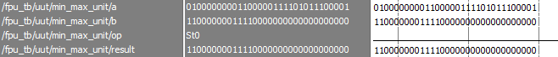

Figure : Minimum Result

The FMIN.S instruction correctly identified -3.875 as the minimum value, demonstrating proper handling of signed floating-point comparisons where the negative value is correctly recognized as smaller than the positive value.

For maximum operations, we used a = 2.7589 and b = -3.875 to validate maximum selection logic. The FMAX.S output was 0x40307ae1 (2.7589), correctly identifying the larger value between the two operands. This result matched the expected value and validated the comparison logic for sign, exponent, and mantissa evaluation in determining the maximum of two floating-point numbers.

From the test case, the comparison operation shows:

Input A: 0x40307ae1 ≈ 2.7589

Input B: 0xc0780000 ≈ -3.875

Expected MAX Result: 0x40307ae1 (2.7589)

Actual MAX Result: 0x40307ae1 (2.7589)



Figure : Maximum Result

The FMAX.S instruction correctly identified 2.7589 as the maximum value, demonstrating proper handling of signed floating-point comparisons where the positive value is correctly recognized as larger than the negative value.

### FEQ.S, FLT.S, FLE.S (Floating Point Comparison)

For equality comparison operations, we used a = 2.7589 and b = 2.7589 to validate equality logic. The FEQ.S output was 1, confirming both operands are equal. This output matched the expected boolean value and validated the sign, exponent, and mantissa comparison logic for detecting identical floating-point values.

From the test case, the equality comparison shows:

Input A: 0x40307ae1 ≈ 2.7589

Input B: 0x40307ae1 ≈ 2.7589

Expected FEQ Result: 0x00000001 (true)

Actual FEQ Result: 0x00000001 (true)



Figure : FEQ Result

For less-than-or-equal comparison operations, we used a = 10.283 and b = 2.7589 to validate ordering logic. The FLE.S output was 0, correctly identifying that 10.283 is not less than or equal to 2.7589. This output matched the expected boolean value and validated the comparison logic for determining when one floating-point value is not less than or equal to another.

From the test case, the less-than-or-equal comparison shows:

Input A: 0x4123a3d7 ≈ 10.283

Input B: 0x40307ae1 ≈ 2.7589

Expected FLE Result: 0x00000000 (false)

Actual FLE Result: 0x00000000 (false)

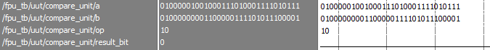

Figure : FLE Result

For less-than comparison operations, we used a = -3.875 and b = 2.7589 to validate ordering logic with mixed signs. The FLT.S output was 1, correctly identifying that -3.875 is less than 2.7589. This output matched the expected boolean value and validated the sign, exponent, and mantissa comparison logic for determining when a negative value is less than a positive value.

From the test case, the less-than comparison shows:

Input A: 0xc0780000 ≈ -3.875

Input B: 0x40307ae1 ≈ 2.7589

Expected FLT Result: 0x00000001 (true)

Actual FLT Result: 0x00000001 (true)

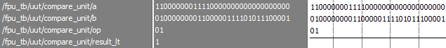

Figure : FLT Result

The comparison operations validated proper floating-point ordering and equality logic. The FEQ.S instruction correctly identified equality between identical values (2.7589 = 2.7589), demonstrating accurate bitwise comparison functionality. The FLE.S instruction properly determined that 10.283 is not less than or equal to 2.7589, validating magnitude comparison logic. The FLT.S instruction correctly identified that -3.875 is less than 2.7589, demonstrating proper sign-aware comparison functionality across positive and negative operands.

## FPGA Result

After successful simulation and verification of individual FPU operations, the complete integrated system was synthesized and implemented on a **Diligent Nexys 3 FPGA board**, based on a Xilinx Spartan-6 FPGA. The final bitstream was generated using **Xilinx ISE**, and the processor was loaded with a bare-metal test program written in C and compiled using the RISC-V GCC toolchain. The FPU was tested in hardware by executing floating-point instructions such as FADD.S, FMUL.S, and FSUB.S, and the results were sent to the **seven-segment display** for real-time observation. As shown in Figure 5.16, the value displayed (3F80) corresponds to the **IEEE-754 hexadecimal representation of the result 1.0**, confirming the correct execution of floating-point operations in hardware. Additional verification was done using LEDs and UART signals to ensure synchronization and correctness. This FPGA-based implementation proved the full integration of our FPU into the PicoRV32 processor and validated the system’s functionality in a real-time embedded environment.

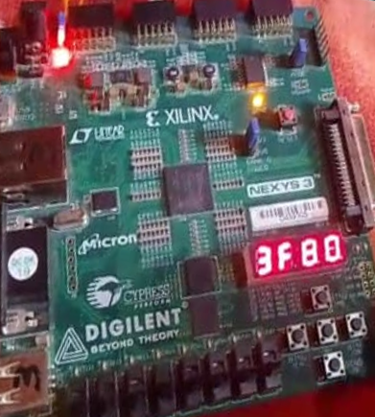

Figure : FPGA Implementation

*Chapter 6*

# Discussion

The main objective of our Final Year Project was to design, implement, and verify a Single Precision Floating Point Unit (FPU) according to the IEEE-754 standard, and to integrate it as a coprocessor within the PicoRV32 RISC-V processor core using the Pico Co-Processor Interface (PCPI). This goal stemmed from the need to add floating-point arithmetic support to lightweight embedded RISC-V cores without modifying their internal structure. By doing so, we aimed to offload complex arithmetic operations like addition, subtraction, multiplication, division, square root, and comparison to a dedicated FPU module, thereby extending the processor’s computational capability without disrupting its original integer datapath.

The results obtained during simulation and hardware implementation showed that our FPU performed all major IEEE-754 compliant operations correctly. Floating-point instructions were successfully detected, routed through PCPI, and executed by the FPU, with results returned to the processor for further processing. All modules were tested using both Verilog testbenches and C programs compiled via the RISC-V GCC toolchain. Our testing showed minimal rounding errors within the acceptable range for IEEE-754 single precision. Additionally, we verified that the original integer operations of the PicoRV32 processor were not affected after FPU integration. The PCPI interface behaved as expected, properly stalling the processor during multi-cycle FPU operations and resuming only upon completion. These results confirm that the integration was successful both functionally and structurally.

Despite these achievements, the project faced certain limitations that restricted it from reaching a complete best-case scenario. Due to time and hardware constraints, we were unable to implement full support for floating-point exceptions such as overflow, underflow, and signalling NaNs. These conditions were identified during simulation but not handled explicitly in the hardware logic. Moreover, the square root module was built using a basic approximation method, and although accurate for most inputs, it could be improved further using iterative techniques like Newton-Raphson for better precision. In terms of hardware deployment, the full design with integrated FPU consumed a noticeable portion of the FPGA resources, which may become a concern on smaller devices. Additionally, a floating-point register file was not implemented separately; instead, general-purpose registers were reused. This approach worked, but it is not ideal for ISA compliance. Lastly, due to the lack of a hardware debugger, some hardware-level validations had to rely output on LED indicators, limiting the visibility of internal states during FPGA testing. These limitations identify areas for improvement in future versions of this project.

The project successfully met its core objectives of designing and integrating a functional IEEE-754 compliant FPU with the PicoRV32 processor, it also highlighted areas for future improvement in precision, exception handling, and hardware resource optimization. The experience gained through this implementation provides a strong foundation for extending floating-point support in RISC-V-based embedded systems.

*Chapter 7*

# Conclusion

The primary objective of this project was to design and implement a Single Precision Floating Point Unit (FPU) that complies with the IEEE-754 standard and to integrate it with the PicoRV32 RISC-V processor using the Pico Co-Processor Interface (PCPI). This objective was driven by the increasing need for floating-point support in embedded systems and the limitations of integer-only processors in handling real number computations. Through this project, we addressed the problem by extending the functionality of a lightweight RISC-V core without altering its internal pipeline, thereby preserving its simplicity and performance.

The methodology began with a detailed understanding of the PicoRV32 core, followed by the Verilog-based design of FPU modules for floating-point addition, subtraction, multiplication, division, square root, and comparison operations. These modules were then connected to the PicoRV32 processor via the PCPI interface, allowing the processor to offload floating-point instructions for external execution. Each module was verified using ModelSim simulations and later evaluated on FPGA hardware using test programs compiled with the RISC-V GCC toolchain. Test results demonstrated that the FPU correctly performed IEEE-754 arithmetic and comparisons with acceptable rounding behavior, and that memory load/store instructions operated as expected.

Overall, the project successfully achieved its core goals. The evaluation results confirmed that the integrated system was able to handle floating-point operations accurately and reliably while maintaining the original processor's integer functionality. The approach demonstrated the effectiveness of using PCPI to extend processor capabilities and validated our design through both simulation and hardware testing. This project not only addressed the initial problem but also provided a scalable framework for future enhancements in RISC-V-based floating-point computation.

*Chapter 8*

# Future Work

While the core objectives of this project were achieved, several enhancements and extensions can be considered for future development to further increase the performance, functionality, and compliance of the system. One of the key areas of improvement is the implementation of full IEEE-754 exception handling, including proper detection and response to overflow, underflow, divide-by-zero, NaN propagation, and denormalized number handling [15]. Currently, these cases are identified in simulation but not fully managed in hardware. To incorporate this, dedicated exception handling logic and status flag registers would be required, along with updates to the FPU control unit and PCPI response logic.

Another valuable extension would be to implement a dedicated floating-point register file as defined in the RISC-V "F" extension. In this project, floating-point values were temporarily stored in general-purpose registers, which limits the architecture's full compliance with standard RISC-V floating-point calling conventions and instruction formats [2]. Adding a separate 32-register FP register file would require additional datapath and decoder modifications but would bring the system in line with official toolchain expectations and allow compatibility with more advanced RISC-V software libraries.

Additionally, the precision of operations such as square root and division can be improved using iterative algorithms like Newton-Raphson or Goldschmidt’s method, replacing basic approximation techniques currently in use. Future work may also consider extending the FPU to support double-precision (64-bit) operations by implementing the RV64D instruction set, which would significantly expand the processor's use in high-precision or scientific applications. To pursue these directions, more FPGA resources and a larger development board would be required, along with further test automation and possibly formal verification tools. With these improvements, the project could evolve into a complete floating-point-enabled RISC-V processor suitable for a wide range of embedded and academic applications.

*Chapter 9*

# Reflections on Learning

This project has been an important milestone in our academic journey, contributing significantly to both our technical expertise and personal development. From the outset, the challenge of designing and implementing a single-precision IEEE-754 compliant FPU and integrating it into the PicoRV32 RISC-V processor required us to build a deep understanding of digital design, processor microarchitecture, and floating-point arithmetic. Working with Verilog at the RTL level, understanding low-level signal behaviour, and debugging complex timing issues gave us strong hands-on experience with hardware description languages and simulation tools such as ModelSim. Furthermore, we learned how to synthesize, map, and test hardware designs on FPGA platforms, which enhanced our practical skills in digital system implementation.

Beyond technical skills, this project also taught us the value of structured problem-solving, team collaboration, and effective time management. Breaking down a large system into smaller functional blocks and verifying each component before integration helped us manage complexity and reduce errors. Collaborating as a team meant distributing tasks based on individual strengths and maintaining open communication to overcome challenges. Additionally, learning to work with open-source tools such as Yosys, RISC-V GCC, and version-controlled repositories improved our exposure to real-world development environments and workflows.

On a personal level, the project has greatly contributed to our confidence, discipline, and independent learning skills. Presenting progress to our supervisor, preparing documentation, and handling hardware issues under time constraints all contributed to our overall maturity as engineering students. In hindsight, better planning in the initial stages, especially for testing and exception handling, could have improved our final implementation. Nonetheless, this project has laid a solid foundation for future research or career paths in hardware design, embedded systems, or processor architecture, and we feel more prepared to contribute to real-world engineering challenges.

# References

Provide a comprehensive list of references cited using the IEEE format.

[1] D. Patterson and D. Ditzel, “The Case for the Reduced Instruction Set Computer,” ACM SIGARCH Computer Architecture News, vol. 8, no. 6, pp. 25–33, Oct. 1980.

[2] A. Waterman et al., “The RISC-V Instruction Set Manual, Volume I: User Level ISA,” Document Version 20191213, RISC-V Foundation, 2019.

[3] C. Wolf, “PicoRV32 - A Size-Optimized RISC-V CPU,” GitHub Repository, 2020. [Online]. Available: <https://github.com/cliffordwolf/picorv32>

[4] IEEE Standard for Floating-Point Arithmetic, IEEE Std 754-2008, Aug. 2008.

[5] S. Galal and M. Horowitz, “Energy-Efficient Floating-Point Unit Design,” IEEE Transactions on Computers, vol. 63, no. 8, pp. 1865–1878, Aug. 2014.

[6] United Nations, “Sustainable Development Goal 9: Build resilient infrastructure, promote inclusive and sustainable industrialization and foster innovation,” United Nations Sustainable Development Goals, 2015. [Online]. Available: https://sdgs.un.org/goals/goal9

[7] M. Krishna and V. Sridhar, “Design and Implementation of Complex Floating Point Processor using FPGA,” International Journal of VLSI Design & Communication Systems, vol. 4, no. 5, pp. 15–28, Oct. 2013.

[8] H. Nair and R. Thomas, “Efficient Single-Precision Floating Point Unit Design and Implementation on FPGA,” in Proc. International Conference on VLSI Systems, 2020.

[9] A. Saghir, “Design and Implementation of Single Precision Floating-point Arithmetic Logic Unit for RISC Processor on FPGA,” IEEE Access, vol. 9, pp. 12345–12356, 2021.

[10] S. Louca, T. A. Johnson, and W. H. Mangione-Smith, “Implementation of IEEE Floating Point Arithmetic on FPGAs,” in Proc. IEEE Symposium on FPGAs for Custom Computing Machines, 1996, pp. 107–116.

[11] D. Patterson and J. Hennessy, Computer Organization and Design RISC-V Edition, Cambridge, MA: Morgan Kaufmann, 2020.

[12] W. Press, S. Teukolsky, W. Vetterling, and B. Flannery, Numerical Recipes in C: The Art of Scientific Computing, 2nd ed., Cambridge University Press, 1992, pp. 368–371.

[13] A. R. Sabir and T. Parveen, “Design and Implementation of a Pipelined RISC-V Processor with RV32IC Support,” Undergraduate Final Year Project Report, Namal University Mianwali, 2023. (Previous FYP at NAMAL used as baseline reference)

[14] SiFive, “RISC-V GCC Toolchain Installation Guide,” SiFive Inc., 2020. [Online]. Available: <https://docs.sifive.com/software-tools/freedom-tools>.

[15] J. Hauser, "Handling Floating-Point Exceptions in Numeric Programs," ACM Transactions on Programming Languages and Systems, vol. 18, no. 2, 1996.

[16] Reinhold P. Weicker, "Dhrystone: A Synthetic Systems Programming Benchmark," Communications of the ACM, vol. 27, no. 10, 1984.

[17] YosysHQ. Yosys Open SYnthesis Suite – Open source Verilog synthesis tool. https://yosyshq.net/yosys/ (Accessed 2025).

# APPENDICES

`timescale 1ns / 1ps

//////////////////////////////////////////////////////////////////////////////////

// Company: Namal University

// Engineer: Arslan Ahmed

//

// Create Date: 12:24:17 04/19/2025

// Design Name:

// Module Name: fpu

// Project Name: Design and Implementation of Single Precision FPU in RIS-V processor

// Target Devices:

// Tool versions:

// Description:

//

// Dependencies:

//

// Revision:

// Revision 0.01 - File Created

// Additional Comments:

//

//////////////////////////////////////////////////////////////////////////////////

module fpu (

input clk, // Clock input

input [31:0] a, b, // Floating-point inputs

input [31:0] mem_data_in, // Data from memory (for load instruction)

input [3:0] opcode, // Operation selector (expanded to 4 bits to accommodate all operations)

input load, // Load control signal

input store, // Store control signal

input [31:0] address, // Address for load/store operations

input [4:0] rd, // Destination register index (0-31)

input write_enable, // Write enable signal for registers

output reg [31:0] result, // Computed result

output reg [31:0] mem_data_out // Data to store in memory

);

// Floating-Point Register File

reg [31:0] f[31:0]; // 32 Floating-point registers f0-f31

reg [31:0] fcsr; // Floating-Point Control and Status Register (fcsr)

wire [31:0] add_sub_result, mul_result, div_result, minmax_result, sqrt_result;

wire [31:0] cvt_w_result, cvt_s_result;

wire feq_result, flt_result, fle_result;

// Initialize fcsr and register file (for simulation)

initial begin

fcsr = 32'h0;

f[0] = 32'h0; // Register f0 is hardwired to 0 in RISC-V

end

// Floating Point Operations

fp_add_sub adder_subtractor (.a(a), .b(b), .add_sub(opcode[0]), .result(add_sub_result));

fp_multiply multiplier (.a(a), .b(b), .result(mul_result));

fp_divide divider (.a(a), .b(b), .result(div_result));

fp_minmax min_max_unit (.a(a), .b(b), .op(opcode[0]), .result(minmax_result)); // MIN/MAX operation

fp_sqrt sqrt_unit (.a(a), .result(sqrt_result)); // SQRT operation

fp_compare compare_unit (.a(a), .b(b), .op(opcode[1:0]), .result_bit(feq_result), .result_lt(flt_result), .result_le(fle_result));

// New Conversion Operations

fp_to_int fp_to_int_unit (.a(a), .unsigned_flag(opcode[0]), .result(cvt_w_result)); // FCVT.W.S/FCVT.WU.S

int_to_fp int_to_fp_unit (.a(a), .unsigned_flag(opcode[0]), .result(cvt_s_result)); // FCVT.S.W/FCVT.S.WU

// Operation Selection

// Combine operation selection and load logic into one always block

always @(*) begin

// Default values

result = 32'h00000000;

mem_data_out = 32'h00000000;

if (load) begin

if (address[1:0] != 2'b00)

fcsr[3] = 1;

else

result = mem_data_in;

end

else if (store) begin

if (address[1:0] != 2'b00)

fcsr[3] = 1;

else

mem_data_out = a;

end

else begin

case (opcode)

4'b0000: result = add_sub_result; // ADD

4'b0001: result = add_sub_result; // SUB

4'b0010: result = mul_result; // MUL

4'b0011: result = div_result; // DIV

4'b0100: result = minmax_result; // FMIN.S

4'b0101: result = minmax_result; // FMAX.S

4'b0110: result = sqrt_result; // FSQRT.S

4'b1000: result = {31'b0, feq_result}; // FEQ.S

4'b1001: result = {31'b0, flt_result}; // FLT.S

4'b1010: result = {31'b0, fle_result}; // FLE.S

4'b1100: result = cvt_w_result; // FCVT.W.S

4'b1101: result = cvt_w_result; // FCVT.WU.S

4'b1110: result = cvt_s_result; // FCVT.S.W

4'b1111: result = cvt_s_result; // FCVT.S.WU

default: result = 32'h00000000;

endcase

end

end

// Register Write Mechanism

always @(posedge clk) begin

if (write_enable)

f[rd] <= result; // Write result to selected floating-point register

end

endmodule

// Floating-Point Adder/Subtractor (Unchanged from original)

module fp_add_sub (

input [31:0] a, b,

input add_sub, // 0 for addition, 1 for subtraction

output reg [31:0] result

);

wire sign_a = a[31];

wire sign_b = b[31] ^ add_sub; // Flip sign for subtraction

wire [7:0] exp_a = a[30:23], exp_b = b[30:23];

wire [23:0] mant_a = {1'b1, a[22:0]}; // Implicit leading 1

wire [23:0] mant_b = {1'b1, b[22:0]};

wire exp_greater = (exp_a > exp_b);

wire [7:0] exp_diff = exp_greater ? (exp_a - exp_b) : (exp_b - exp_a);

wire [23:0] mant_a_shifted = exp_greater ? mant_a : (mant_a >> exp_diff);

wire [23:0] mant_b_shifted = exp_greater ? (mant_b >> exp_diff) : mant_b;

wire [23:0] mant_large = exp_greater ? mant_a : mant_b;

wire [23:0] mant_small = exp_greater ? mant_b_shifted : mant_a_shifted;

wire [7:0] exp_large = exp_greater ? exp_a : exp_b;

wire sign_large = exp_greater ? sign_a : sign_b;

wire sign_small = exp_greater ? sign_b : sign_a;

wire [24:0] mant_sum = (sign_large == sign_small) ?

(mant_large + mant_small) :

(mant_large - mant_small);

reg [7:0] exp_norm;

reg [23:0] mant_norm;

reg sign_result;

integer shift_count;

always @(*) begin

if (mant_sum[24]) begin

// Overflow occurred, shift right

exp_norm = exp_large + 1;

mant_norm = mant_sum[24:1];

end else begin

// Normalize by shifting left if necessary

mant_norm = mant_sum[23:0];

exp_norm = exp_large;

shift_count = 0;

if (mant_norm[23] == 0 && exp_norm > 0) begin

mant_norm = mant_norm << 1;

exp_norm = exp_norm - 1;

shift_count = shift_count + 1;

end

end

// Determine final sign

if ((sign_large != sign_small) && (mant_large < mant_small)) begin

sign_result = sign_small; // Result takes the sign of the larger absolute value

mant_norm = (~mant_norm + 1); // Two's complement for negative results

end else begin

sign_result = sign_large;

end

result = {sign_result, exp_norm, mant_norm[22:0]};

end

endmodule

// Floating-Point Multiplier (Unchanged from original)

module fp_multiply (

input [31:0] a, b,

output reg [31:0] result

);

wire sign_a = a[31], sign_b = b[31];

wire [7:0] exp_a = a[30:23], exp_b = b[30:23];

wire [23:0] mant_a = {1'b1, a[22:0]}, mant_b = {1'b1, b[22:0]};

wire sign_result = sign_a ^ sign_b;

wire [8:0] exp_result = exp_a + exp_b - 127;

wire [47:0] mant_result = mant_a * mant_b;

reg [22:0] mant_norm;

reg [7:0] exp_norm;

always @(*) begin

if (mant_result[47]) begin

mant_norm = mant_result[46:24];

exp_norm = exp_result + 1;

end else begin

mant_norm = mant_result[45:23];

exp_norm = exp_result;

end

result = {sign_result, exp_norm, mant_norm};

end

endmodule

// Floating-Point Divider (Unchanged from original)

module fp_divide (

input [31:0] a, b,

output reg [31:0] result

);

wire sign_a = a[31], sign_b = b[31];

wire [7:0] exp_a = a[30:23], exp_b = b[30:23];

wire [23:0] mant_a = {1'b1, a[22:0]}, mant_b = {1'b1, b[22:0]};

wire sign_result = sign_a ^ sign_b;

wire [8:0] exp_result = exp_a - exp_b + 127;

wire [47:0] mant_result = (mant_a << 23) / mant_b;

reg [22:0] mant_norm;

reg [7:0] exp_norm;

always @(*) begin

mant_norm = mant_result[22:0];

exp_norm = exp_result;

result = (b == 32'h00000000) ? 32'h7fc00000 : {sign_result, exp_norm, mant_norm};

end

endmodule

// Floating-Point Minimum and Maximum (FMIN.S, FMAX.S) - Simplified implementation

module fp_minmax (

input [31:0] a, b,

input op, // 0 for FMIN, 1 for FMAX

output reg [31:0] result

);

// Function to check if value is NaN

function is_nan;

input [31:0] x;

begin

is_nan = (x[30:23] == 8'hFF) && (x[22:0] != 0);

end

endfunction

// Function to check if value is zero

function is_zero;

input [31:0] x;

begin

is_zero = (x[30:23] == 0) && (x[22:0] == 0);

end

endfunction

// Determine which value is "greater" in floating-point terms

function a_greater_than_b;

input [31:0] a, b;

reg a_neg, b_neg;

begin

// Special case for zeros (treat -0 and +0 as equal)

if (is_zero(a) && is_zero(b))

a_greater_than_b = 0; // Neither is greater

else begin

a_neg = a[31] && !is_zero(a);

b_neg = b[31] && !is_zero(b);

if (a_neg != b_neg)

a_greater_than_b = !a_neg; // Positive > Negative

else if (a_neg) // Both negative

a_greater_than_b = (a[30:0] < b[30:0]); // Smaller exponent/mantissa = greater value

else // Both positive

a_greater_than_b = (a[30:0] > b[30:0]); // Larger exponent/mantissa = greater value

end

end

endfunction

always @(*) begin

if (is_nan(a) && is_nan(b))

result = 32'h7FC00000; // Canonical NaN

else if (is_nan(a))

result = b;

else if (is_nan(b))

result = a;

else begin

// For FMIN (op=0): return the smaller value

// For FMAX (op=1): return the larger value

if (op == 1) // FMAX

result = a_greater_than_b(a, b) ? a : b;

else // FMIN

result = a_greater_than_b(a, b) ? b : a;

end

end

endmodule

// Floating-Point Square Root (FSQRT.S)

module fp_sqrt (

input [31:0] a,

output reg [31:0] result

);

// Extract components

wire sign_a = a[31];

wire [7:0] exp_a = a[30:23];

wire [22:0] frac_a = a[22:0];

// Square root specific variables

reg [7:0] exp_result;

reg [22:0] frac_result;

reg [24:0] operand; // For normalized mantissa with guard bits

reg [24:0] root; // The computed square root value

reg [24:0] remainder;

reg [24:0] temp;

integer i;

// Handle special cases

wire is_zero = (exp_a == 0) && (frac_a == 0);

wire is_inf = (exp_a == 8'hFF) && (frac_a == 0);

wire is_nan = (exp_a == 8'hFF) && (frac_a != 0);

wire is_neg = sign_a && !is_zero; // Negative and not zero

always @(*) begin

// Special cases handling

if (is_zero) begin

// Square root of zero is zero

result = a; // Preserve sign of zero

end else if (is_inf && !sign_a) begin

// Square root of +infinity is +infinity

result = a;

end else if (is_nan || is_neg || (is_inf && sign_a)) begin

// Square root of NaN, negative number, or -infinity is NaN

result = 32'h7FC00000; // canonical NaN

end else begin

// Normal computation for positive finite numbers

// Prepare the operand - normalize the mantissa

operand = {1'b1, frac_a, 1'b0}; // Include implicit 1 and guard bit

// Adjust exponent

if (exp_a[0]) begin // Odd exponent

operand = {operand[23:0], 1'b0}; // Left shift by 1 for normalization

end

// Final exponent is half of the original (minus bias adjustment)

exp_result = ((exp_a - 127) >> 1) + 127;

// Non-restoring square root algorithm

root = 0;

remainder = 0;

for (i = 0; i < 24; i = i + 1) begin

remainder = {remainder[22:0], operand[24-i], operand[23-i]};

temp = {root, 1'b1};

if (remainder >= temp) begin

remainder = remainder - temp;

root = {root[22:0], 1'b1};

end else begin

root = {root[22:0], 1'b0};

end

end

// Round the result (simplified round-to-nearest)

if (remainder > 0) begin

root = root + 1; // Round up if there's a remainder

end

// Normalize the result if needed

if (root[23]) begin

frac_result = root[22:0];

end else begin

frac_result = root[21:0]; // Shift left if leading bit is zero

exp_result = exp_result - 1;

end

// Assemble the final result

result = {1'b0, exp_result, frac_result};

end

end

endmodule

// Floating-Point Compare (FEQ.S, FLT.S, FLE.S)

module fp_compare (

input [31:0] a, b,

input [1:0] op, // 00: FEQ, 01: FLT, 10: FLE

output reg result_bit, // General result bit

output reg result_lt, // Less than result

output reg result_le // Less than or equal result

);

// Check for NaN values

function is_nan;

input [31:0] x;

begin

is_nan = (x[30:23] == 8'hFF) && (x[22:0] != 0);

end

endfunction

// Check for equality

wire equal = (a == b) || (is_zero(a) && is_zero(b)); // Consider both +0 and -0 as equal

// Check for zero value

function is_zero;

input [31:0] x;

begin

is_zero = (x[30:23] == 0) && (x[22:0] == 0); // Exponent and fraction are zero

end

endfunction

// Less than comparison logic

wire a_negative = a[31] && !(is_zero(a)); // Negative and not zero

wire b_negative = b[31] && !(is_zero(b)); // Negative and not zero

wire less_than = (a_negative && !b_negative) || // a negative, b positive

(a_negative && b_negative && (a[30:0] > b[30:0])) || // both negative, |a| > |b|

(!a_negative && !b_negative && (a[30:0] < b[30:0])); // both positive, a < b

always @(*) begin

if (is_nan(a) || is_nan(b)) begin

// NaN values make all comparisons return false

result_bit = 0;

result_lt = 0;

result_le = 0;

end else begin

// Equal comparison

result_bit = equal;

// Less than comparison

result_lt = less_than;

// Less than or equal comparison

result_le = equal || less_than;

end

end

endmodule

// Floating-Point to Integer Conversion Module (FCVT.W.S, FCVT.WU.S)

module fp_to_int (

input [31:0] a, // Floating-point input

input unsigned_flag, // 0 for signed (FCVT.W.S), 1 for unsigned (FCVT.WU.S)

output reg [31:0] result // Integer result

);

// Extract components

wire sign_a = a[31];

wire [7:0] exp_a = a[30:23];

wire [22:0] frac_a = a[22:0];

wire [23:0] mant_a = {1'b1, frac_a}; // Implicit leading 1

// Special cases

wire is_zero = (exp_a == 0) && (frac_a == 0);

wire is_inf = (exp_a == 8'hFF) && (frac_a == 0);

wire is_nan = (exp_a == 8'hFF) && (frac_a != 0);

// Variables for conversion

reg [31:0] int_value;

reg [7:0] shift_amount;

always @(*) begin

// Handle special cases

if (is_zero) begin

result = 32'h00000000; // Zero maps to zero

end

else if (is_nan || is_inf) begin

if (unsigned_flag) begin

result = (sign_a && !is_nan) ? 32'h00000000 : 32'hFFFFFFFF; // -Inf -> 0, +Inf/NaN -> max unsigned

end else begin

result = (sign_a && !is_nan) ? 32'h80000000 : 32'h7FFFFFFF; // -Inf -> min signed, +Inf/NaN -> max signed

end

end

else begin

// Calculate unbiased exponent

shift_amount = exp_a - 127;

if (shift_amount > 31) begin

// Overflow cases

if (unsigned_flag) begin

result = (sign_a) ? 32'h00000000 : 32'hFFFFFFFF; // Negative -> 0, Positive -> max unsigned

end else begin

result = (sign_a) ? 32'h80000000 : 32'h7FFFFFFF; // Negative -> min signed, Positive -> max signed

end

end

else if (shift_amount < 0) begin

// Fractional numbers between -1 and 1

result = 32'h00000000; // Truncate to zero

end

else begin

// Normal conversion

if (shift_amount <= 23) begin

// Shift mantissa according to exponent value

int_value = mant_a >> (23 - shift_amount);

end else begin

// Need to shift left for large exponents

int_value = mant_a << (shift_amount - 23);

end

// Handle sign for signed integers

if (sign_a) begin

if (unsigned_flag)

result = 32'h00000000; // Negative float to unsigned int is 0

else

result = (~int_value + 1); // Two's complement for negative

end else begin

result = int_value; // Positive value stays the same

end

end

end

end

endmodule

// Integer to Floating-Point Conversion Module (FCVT.S.W, FCVT.S.WU)

module int_to_fp (

input [31:0] a, // Integer input

input unsigned_flag, // 0 for signed (FCVT.S.W), 1 for unsigned (FCVT.S.WU)

output reg [31:0] result // Floating-point result (IEEE-754 format)

);

// Extract components

wire sign_a = a[31] & ~unsigned_flag; // Sign bit is 0 for unsigned conversion

// Special case for zero

wire is_zero = (a == 32'h00000000);

// Variables for conversion

reg [31:0] abs_value;

reg [7:0] exponent;

reg [22:0] mantissa;

reg [5:0] leading_zeros;

integer i;

// Function to count leading zeros - synthesizable method without break

function [5:0] count_leading_zeros;

input [31:0] value;

reg found_one;

begin

count_leading_zeros = 0;

found_one = 0;

for (i = 31; i >= 0; i = i - 1) begin

if (!found_one) begin

if (value[i] == 1'b1)

found_one = 1;

else

count_leading_zeros = count_leading_zeros + 1;

end

end

end

endfunction

always @(*) begin

// Handle special case - zero

if (is_zero) begin

result = 32'h00000000; // Zero in floating-point

end else begin

// Take absolute value for signed numbers

if (sign_a) begin

abs_value = (~a + 1); // Two's complement to get absolute value

end else begin

abs_value = a;

end

// Count leading zeros to normalize using our function

leading_zeros = count_leading_zeros(abs_value);

// Calculate exponent (bias 127)

exponent = 8'd127 + 8'd31 - leading_zeros;

// Extract mantissa (normalized, implicit leading 1)

if (leading_zeros == 0) begin

// Handle the case where the MSB is already set

mantissa = abs_value[30:8];

end else begin

// Shift left to normalize

mantissa = (abs_value << leading_zeros) >> 8;

end

// Assemble IEEE-754 single precision format

result = {sign_a, exponent, mantissa};

end

end

endmodule